



ESSB 5814 - Services newly subject to retail sales tax


Moderators

..•.

T

Darlene arner
Tax Policy Specialist

WASHINGTON STATE DEPARTMENT OF REVENUE



Agenda

- Overview of ESSB 5814.
- Advertising services.
- Information Technology services.
- Live presentations.
- Temporary staffing services.
- Security services.
- Existing Contracts.
- Resources.

W AS H I N G T O N S T AT E D E P A R T M E N T O F R E V E N U E
3

Ask us questions!


Telephone Information Center: 360-705-6705 M-F, 8am-5pm, Wed from 9am-5pm
WASHINGTON STATE DEPARTMENT OF REVENUE

Sales tax on invoice

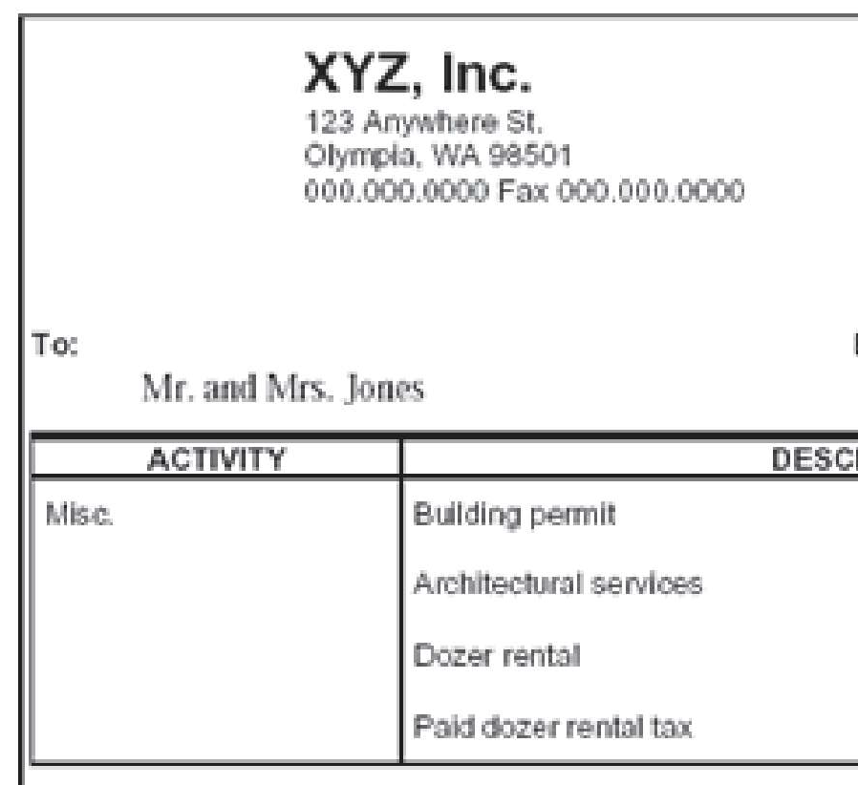
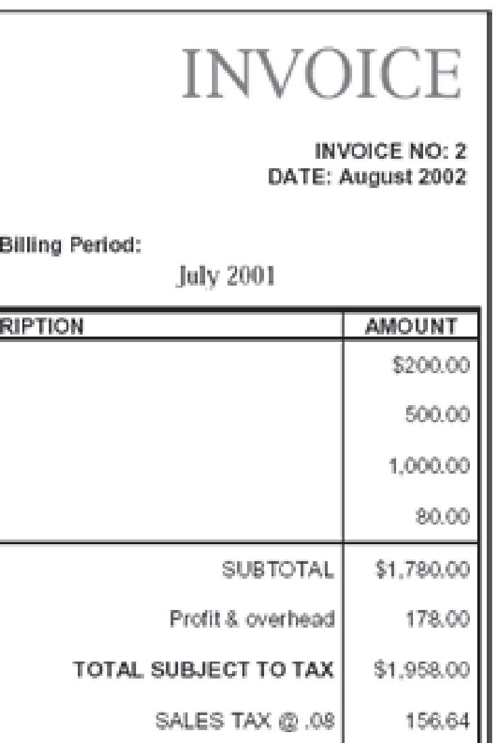
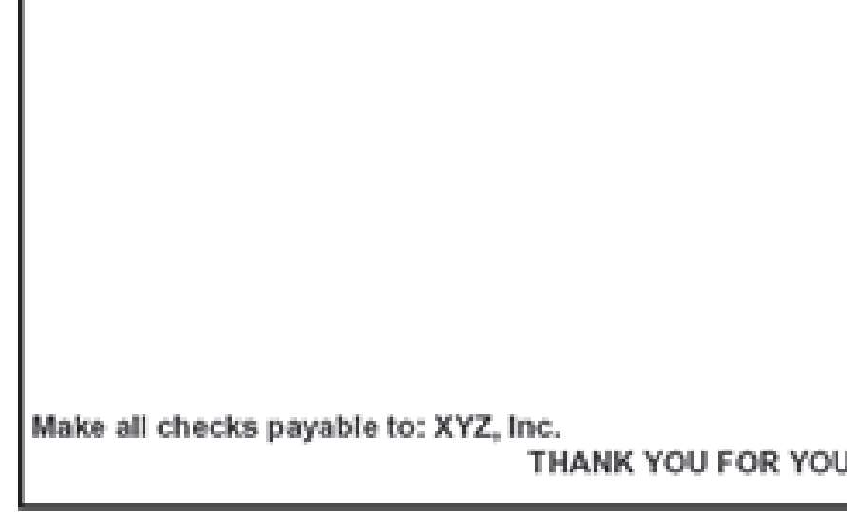

- Retail sales tax required on the following: Customer sales slips.
Contracts.
  - Invoices.
  - Receipt.
Other sales documents.

WASHINGTON STATE DEPARTMENT OF REVENUE

Gross income vs. net income

Gross income. Net income = Charge minus:
Cost of good sold.
    - Labor. Overhead.
    - Total= net income.



WASHINGTON STATE DEPARTMENT OF REVENUE

Sourcing retail sales


Retail sales tax general sourcing rules:
- Business location.
- Place of receipt.
- Address in business records.
- Address obtained during sale.
  - Internet protocol (IP) address.
- Origin.

WASHINGTON STATE DEPARTMENT OF REVENUE

Retail sales tax tools

- Tax Rate Lookup Tool. Mobile app.
- Data downloads.
Google Play App Store

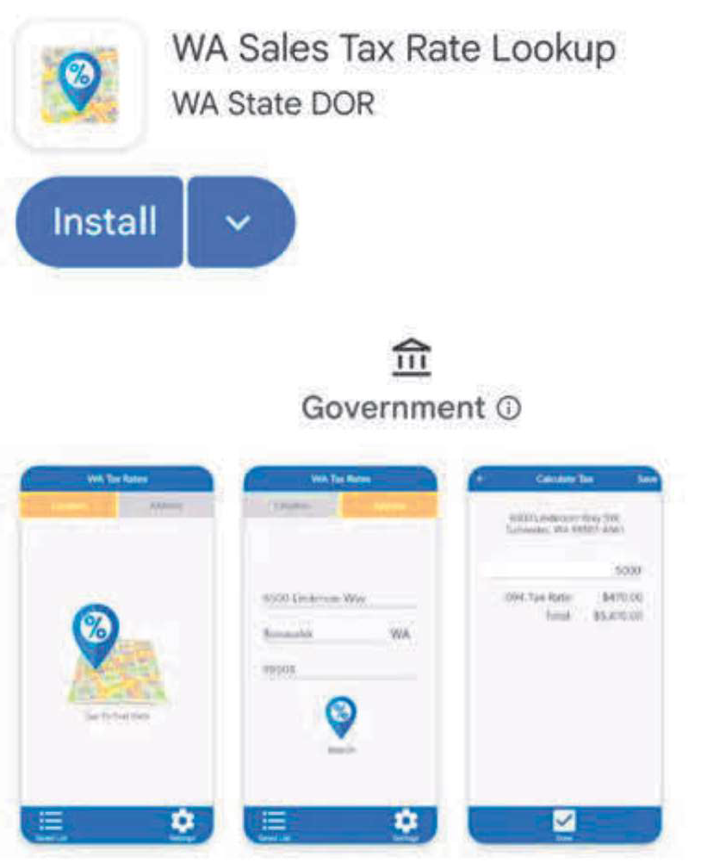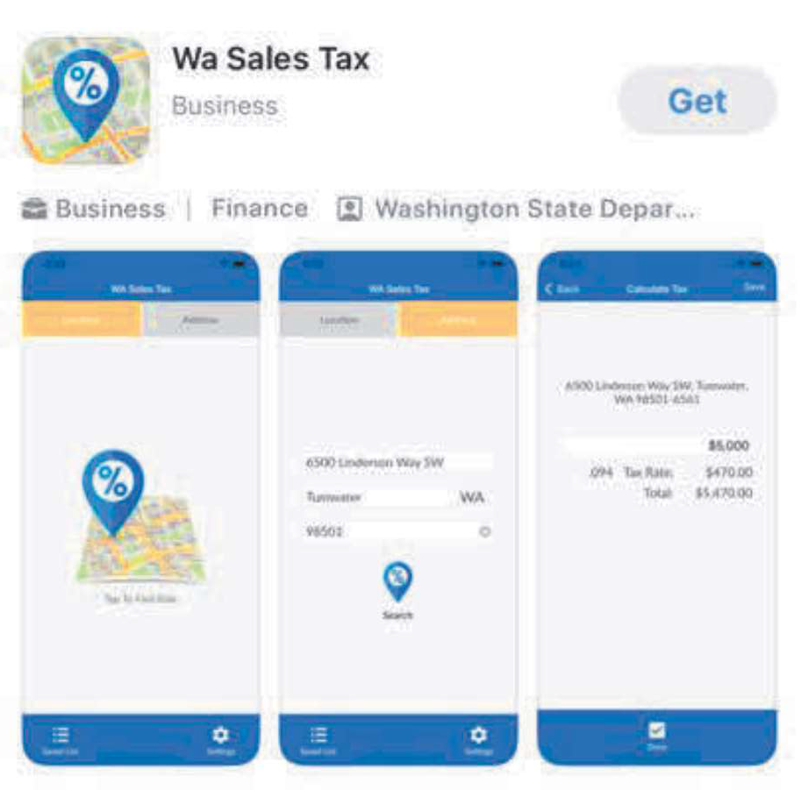
WASHINGTON STATE DEPARTMENT OF REVENUE





5814?

Services newly subject to retail sales tax

Effective October 1, 2025:
Advertising services.
Custom software and the customization of prewritten software. Custom website development services.
  - Information technology services.
  - Investigation, security, and armored car services.
  - Live presentations.
  - Temporary staffing services.

WASHINGTON STATE DEPARTMENT OF REVENUE

Exclusions removed from Digital Automated Services

Services involving primarily human effort.
  - Live presentations. Advertising services.
  - Data processing services.

W AS H I N G T O N S T AT E D E P A R T M E N T O F R E V E N U E
11





under ESSB 5814


Interim Guidance Statement Summary:


What are advertising services?
I

Advertising Services

    - All digital and nondigital advertising services related to:
      - Creation.
      - Preparation.
      - Production.
      - Dissemination.

WASHINGTON STATE DEPARTMENT OF REVENUE

What are advertising services?
I

Advertising Services

    - Creation, preparation, and production of advertising:
      - Layout, art direction, and graphic design.
      - Mechanical preparation.
      - Production supervision.
      - Placement.
      - Referrals.
Acquisition of advertising space.
      - Rendering advice concerning the best methods of advertising products or services.

WASHINGTON STATE DEPARTMENT OF REVENUE

What are advertising services?
I

Advertising Services

    - Dissemination of advertising:
      - Online referrals.
      - Search engine marketing.
      - Lead generation optimization.
      - Web campaign planning.
Acquisition of advertising space in the internet media.
      - Monitoring and evaluation of website traffic for purposes of determining the effectiveness of an advertising campaign.

WASHINGTON STATE DEPARTMENT OF REVENUE

Advertising

Does not include:

- Web hosting services and domain name registration.
- Services rendered in respect to:
  - Newspapers as defined in RCW 82.04.214
  - Printing or publishing under RCW 82.04.280
  - Radio and television broadcasting within this state as defined in RCW 82.04.281

W AS H I N G T O N S T AT E D E P A R T M E N T O F R E V E N U E 17
Services

Advertising

Does not include:

- Services rendered in respect to out-of-home advertising, including:
  - Billboard advertising.
  - Street furniture advertising.
  - Transit advertising.
  - Place-based advertising such as:
    - In-store display advertising.
    - Point-of-sale advertising.
    - Dynamic or static signage at live events.
Naming rights.
    - Fixed signage advertising.

W AS H I N G T O N S T AT E D E P A R T M E N T O F R E V E N U E 18
Services

Interim Guidance Statement Summary:

What are information technology services?
I

IT Services include
- Assisting with network operations and support.
- Help desk services.
- In-person training related to hardware or software.
- Network system support services.
- Data entry services.
- Data processing services.

WASHINGTON STATE DEPARTMENT OF REVENUE

IT Services do not include

- Web hosting, domain name registration, and payment processing services.
- Sales of digital automated services, including software as a service.
- Sales of remote access software.
- Cryptocurrency mining activities.
- Telecommunications services and ancillary services.

W AS H I N G T O N S T AT E D E P A R T M E N T O F R E V E N U E 21

Interim Guidance Statement Summary:

Digital Automated Service exclusion eliminated as October 1, 2025.
I

Live presentations
- Live presentations includes:
  - Lectures.
  - Seminars. Workshops.
  - Courses attended in person or via the internet.
  - Telecommunications equipment that allows audience members to discuss information in real time.
- Exclusion available for higher education (Private and Public).

WASHINGTON STATE DEPARTMENT OF REVENUE

Not Live

- Performances such as concerts, plays, musicals, comedy shows, and opera.
- Movies.
- Sports events.
- Fundraising events.
- One-on-one instructional activities such as tutoring, consulting, or music lessons.
- Professional services where the presentation is merely a part of delivering a broader service to the client

W AS H I N G T O N S T AT E D E P A R T M E N T O F R E V E N U E 24

Presentations

Not Live

- Pre-recorded presentations
- Athletic and fitness activities that are separately classified under the definition of an "athletic fitness facility"
- Recreational activities.
- "Opportunity to dance" as these activities maintain their specified tax classification.

W AS H I N G T O N S T AT E D E P A R T M E N T O F R E V E N U E 25
Presentations

Interim Guidance Statement Summary:

hat are

- The taxpayer recruits and hires their own employees.
- The taxpayer finds other organizations that need the services of those employees.
- The taxpayer customarily attempts to reassign the employees to other organizations when they finish each assignment.

W AS H I N G T O N S T AT E D E P A R T M E N T O F R E V E N U E 27
temporary staffing services?

What are temporary staffing services?

- The taxpayer directs and supervises those employees and assigns them on a temporary basis to:
  - Perform work at or services for the other organizations to support or supplement the other organizations' workforces.
  - Provide assistance in special work situations such as, but not limited to, employee absences, skill shortages, seasonal workloads.
  - Perform special assignments or projects.

W AS H I N G T O N S T AT E D E P A R T M E N T O F R E V E N U E 28










Temporary Staffing

W AS H I N G T O N S T AT E D E P A R T M E N T O F R E V E N U E
29

Interim Guidance Statement Summary:


- Private detective services.
I

hat are
Investigation
services?
- Background check services.
- Fingerprint services.
- Bounty hunting services.
- Private investigation services.
- Lie detection and polygraph services.
- Missing person tracing services.
- Skip tracing services.

WASHINGTON STATE DEPARTMENT OF REVENUE

hat are security, security

- Security guard and patrol services.
- Personal and event security.
- Armored car transportation of cash and valuables.
- Security system services and monitoring, including electronically transferred systems.

W AS H I N G T O N S T AT E D E P A R T M E N T O F R E V E N U E 32
monitoring,

and armored car services?

Does not include:
I

Investigation, security, security monitoring, and armored car servi• ces

- Locksmith services.
- Forensic accounting services.
- Internal human resources investigations.
- Cyber security services.
- Process servers.

WASHINGTON STATE DEPARTMENT OF REVENUE










Interim Guidance Statement Summary:



hat is an existing contract?

The contract was signed and executed prior to October 1, 2025.

The underlying services are to be provided on or will continue after October 1, 2025.

The underlying services of the contract would be considered a "retail sale" effective October 1, 2025.

W AS H I N G T O N S T AT E D E P A R T M E N T O F R E V E N U E 36

Must meet all three
requirements.

Example: Eligible contract

Scenario:
- TechFriendly is an IT firm that specializes in providing IT training and help desk services.
- They recently signed a contract with Client Co. to provide their services starting October 1, 2025, through October 1, 2026. TechFriendly and Client Co. signed and executed their contract on September 15, 2025.

WASHINGTON STATE DEPARTMENT OF REVENUE

Example: Eligible contract

Result:
- This contract meets the requirements of an existing contract.

WASHINGTON STATE DEPARTMENT OF REVENUE

How are existing contracts taxed?

- The department deems the sale to have occurred prior to October 1, 2025.

- Accordingly, the transaction is not subject to retailing B&O or retail sales tax.

- Does not matter whether the seller maintains cash or accrual basis.

W AS H I N G T O N S T AT E D E P A R T M E N T O F R E V E N U E 39

Contract price paid prior to Oct. 1, 2025, but services are provided on or continue after Oct. 1, 2025.

Example: Payment before Oct. 01, 2025

- IT Firm LLC provides information technology support and training services that would be considered a taxable retail sale as of October 1, 2025.
- IT Firm LLC enters into a contract with Big Biz Inc. to provide IT training and support services starting October 1, 2025, and ending June 30, 2026.
IT Firm LLC and Big Biz Inc. sign and execute the contract on September 30, 2025, and Big Biz Inc. pays the full contract price the same day.

W AS H I N G T O N S T AT E D E P A R T M E N T O F R E V E N U E
40

Example: Payment before Oct. 01, 2025

IT Firm LLC may report the gross income it received from Big Biz Inc. on September 30, 2025, under the Service and Other Activities B&O tax classification and is not required to collect and submit retail sales tax on the gross amount received from this contract.

W AS H I N G T O N S T AT E D E P A R T M E N T O F R E V E N U E
41

How are existing contracts taxed?

- The department will accept tax reporting under the tax classification applied to the underlying contract activity prior to October 1, 2025.
Tax treatment will apply through March 31, 2026.
- Seller must begin reporting Retailing B&O and collect retail sales tax on April 1, 2026.

W AS H I N G T O N S T AT E D E P A R T M E N T O F R E V E N U E 42

Example: Existing Contract

Scenario:
- IT Firm LLC provides information technology support and training services that would be considered a taxable retail sale as of October 1, 2025.
- IT Firm LLC enters into a contract with Big Biz Inc. to provide IT training and support services starting October 1, 2025, and ending September 30, 2026.
IT Firm LLC and Big Biz Inc. sign and execute the contract before October 1, 2025.
- The contract requires Big Biz Inc. to pay at the end of each month based on the number of their employees that require IT support and training.

WASHINGTON STATE DEPARTMENT OF REVENUE

Example: Existing Contract

Result:
- IT Firm LLC may report the amounts it receives from its "existing" contract with Big Biz Inc. under the Service and Other Activities B&O tax classification and is not required to collect and submit retail sales tax on the gross amount through March 31, 2026.
- For reporting periods beginning on or after April 1, 2026, IT Firm LLC must instead report the amounts it receives from Big Biz Inc. under the Retailing B&O tax classification and must collect and submit retail sales tax on the gross amount received.

WASHINGTON STATE DEPARTMENT OF REVENUE

Existing contracts that are altered after October 1, 2025, are subject to retailing B&O and retail sales tax.
I

Altered Existing Contracts

  - The addition, removal, or exchange of the parties subject to the contact.
  - Changes to the underlying contract activities.
  - Updates to contractual terms that impact any of the parties' rights, responsibilities, or obligations under the contract.
  - Updates or changes to the contractual term, contract term, or period the contract is in effect.

WASHINGTON STATE DEPARTMENT OF REVENUE

-[i] Website

Contact Us
dor.wa.gov
a Phone Number
360-705-6705

� Letter Ruling
DORRulings@dor.wa.gov

Questions?

W AS H I N G T O N S T AT E D E P A R T M E N T O F R E V E N U E
47

