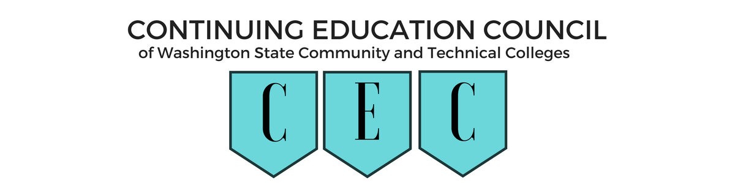

**INVOICE FOR ANNUAL DUES**

2020-2021

College Name: **Click or tap here to enter text.** Amount due: **$75.00**\*

|  |  |  |
| --- | --- | --- |
| Voting Member** Name: | Email | Title |
| Click or tap here to enter text. | Click or tap here to enter text. | Click or tap here to enter text. |
| Additional Member Names: |  |  |
| Click or tap here to enter text. | Click or tap here to enter text. | Click or tap here to enter text. |
| Click or tap here to enter text. | Click or tap here to enter text. | Click or tap here to enter text. |
| Click or tap here to enter text. | Click or tap here to enter text. | Click or tap here to enter text. |
| Click or tap here to enter text. | Click or tap here to enter text. | Click or tap here to enter text. |
| Click or tap here to enter text. | Click or tap here to enter text. | Click or tap here to enter text. |

Continuing Education Council dues are **$150* a year for each college**. The dues cover the program costs for the Council. If the Council has an an-person meeting this year, a College may send up to **two** representatives for a meeting fee of $45. (Additional staff may attend at the cost of $20 per person.) The fee will be used to cover food costs associated with the meeting.

Checks should be made payable to:

**Continuing Education Council**

**Attention: Christy Isaacson**

**North Seattle College**

**9600 College Way N**

**Seattle, WA 98103**

The CEC Taxpayer ID number is: 91-1613501

If you have any questions, please email at [christy.isaacson@seattlecolleges.edu](mailto:christy.isaacson@seattlecolleges.edu)

Christy Isaacson, Treasurer, Continuing Education Council

North Seattle College