Putting together a data governance program at your college

What is data governance? Data Governance is an emerging discipline that combines data management, data quality and data policies through a system of decision rights. It is not a one-time effort but requires ongoing monitoring to promote continuous improvement. It deals primarily with orchestrating and standardizing the efforts of people and processes to optimize data integrity and quality. A committee focused on standardizing data collection/interpretation/reporting is very helpful in improving reporting efforts and ensuring all impacted stakeholders are on the same page.

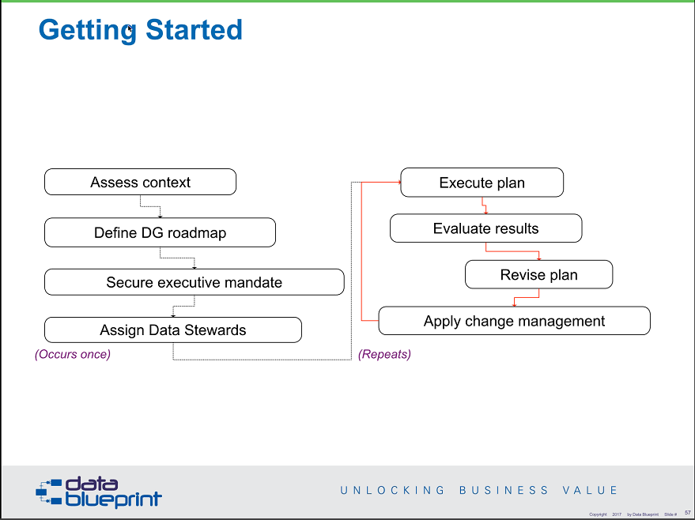

Useful resources: <https://www.sbctc.edu/colleges-staff/commissions-councils/dgc/resources.aspx>

# Why do you need data governance? What are the things you really need to do but are not able to do at your college because accurate data is not there to support your efforts? What can data do for your college?

LIST

# Next, identifying your existing data.

We know data divides into at least these three high level categories in the WA CTC system:

* 1. Student (SMS / CS)
  2. HR (PPMS / HCM)
  3. Finance (FMS, FM)

It is most useful if you divide your data into smaller groups than above. Also include other data that is collected at your college. Some of your data may be entered into one system and then moved. For this initial assessment focus on systems you enter the data

Create a grid using the RACI model. Determine who is responsible for the data, who collects and enters this data? What administrator is accountable for this data? What areas should be consulted regarding this data if there are changes to be made? Who needs to be informed of changes?

You will need to make a decision about who should be accountable for data. This needs to be someone who has the authority to monitor data and implement changes.

|  |  |  |  |  |  |  |  |  |
| --- | --- | --- | --- | --- | --- | --- | --- | --- |
| Data   * systems | | Responsible (Data Stewards) | | Accountable (Administrators) | | Consulted | Informed | |
| **Student (SMS / CS)** | | | | | | | | |
| Admissions   * SMS   *Including demographics* | | Enrollment Services | | Director of Enrollment Services and Dean of Student Enrollment and Completion | | Entry Services, Planning and Effectiveness | Advising, Instruction | |
| **Instruction / Course & Curriculum Management** | | | | | | | | |
|  | |  | |  | |  |  | |
| **HR, Employee Access (PPMS / HCM)** | | | | | | | | |
|  | |  | |  | |  |  | |
| **Finance (FMS, FM)** | | | | | | | | |
|  | |  | |  | |  |  | |
| **Other Systems** | | | | | | | | |
|  |  | |  | |  | | |  |
| External systems we provide individual level data to | | | | | | | | |
|  | |  | |  | |  |  | |

Your college may want to add to this grid, either during the initial collection phase or as a second phase. One valuable addition is the four categories of data classification. An additional item may be to indicate if the data is “master” data or if the data is considered “supplemental”.

It may also be useful to list all the departments at your college and assess what data is used in each area. Additionally, if your college has begun work on the ctcLink project you, may have an inventory of your supplemental systems which can help with this task.

# Identify the required people for Data Governance.

Identify the people and the type of group they should form: Based on the work you did above to identify the data and who is responsible you will put together a governance group that includes people from each group. Many of the same groups which are responsible will also be listed as consulted and informed. Who are the people at your college who arer passionate about data? What kind of group do you need? This is about governance so it should be a group with the authority to implement policy and procedures. What fits best within the existing structure of your college? The goal of your Data Governance program should be to be “non-invasive”. You don’t want to create a new and different structure – you already have a structure around your data. Data Governance is about defining and documenting that structure.

# What kind of group do you need?

This is about governance so it should be a group with the authority to implement policy and procedures. What fits best within the existing structure of your college? The goal of your Data Governance program should be to be “non-invasive.” A new data governance committee will likely have greater impact if it is built into the existing shared governance system on campus, rather than its own standalone committee. You don’t want to create a new and different structure – you already have a structure around your data. Data Governance is about defining and documenting that structure.

# Communications

How will people on your campus be informed about the work of data governance? Where can they go to find information? Need both push and pull information.

# Identify what written policies and procedures exist at your institution regarding data.

Don’t be surprised if you have very little of this written down.

These policies and procedures may fall into the following categories:

* Risk management
  + Suggest migration of heavily manual procedures to standardized procedures that are automated by technology
* Data compliance and regulatory control
  + HIPAA
  + FERPA
  + Record retention laws
  + Federal financial aid compliance
  + International ???
* Data storage. Where is data and information allowed to be stored at your college? Can employees use Google Docs, Box, etc? Cloud storage – what can be stored here. Hard drives, thumb drives, etc.
* Data access
  + Who can access what data
  + What is criteria / need for access
  + Process
  + Temporary or permanent access
  + How is access monitored and removed
* Data classification - Certain types of information must be strictly protected. Once information is classified, appropriate security measures must be taken to maintain the confidentiality of that information.
  + Category 1 – Public Information
  + Category 2 – Sensitive Information
  + Category 3 – Confidential Information
  + Category 4 – Confidential Information Requiring Special Handling
* Master data management – consistently define and manage the critical **data** of an organization to provide a single point of reference
* Meta-data management. When there are no implemented standards or methods for sharing data, it is practically impossible to ensure accuracy and consistency of reporting analytics or decision making.
  + Meaningful, managed, collaborative environment.
  + Data curation.
  + Centralized documentation.
  + Data dictionary.
* Data quality and management
* Business intelligence and data integration
  + Define and manage information integrity, availability and confidentiality standards
  + Self service reporting and analysis
* Data governance
  + Purpose – Why do you need data governance (see question 1), formalizing what you already do.
  + Scope – what and who does this include
    - Security
    - Integrity
    - Availability
  + What is the program
  + Responsibilities. Identify Data Stewards
  + Enforcement
  + Training

For each of these, you should identify who is responsible and accountable. Are there individuals / departments at the college or should this be part of your data governance committee?

# Resources:

The Data Governance Committee maintains a list of resources at <https://www.sbctc.edu/colleges-staff/commissions-councils/dgc/resources.aspx>.

SBCTC Data Services metaLink – a public search tool, or login to view the data dictionary is located at <https://dataservicesmetalink.sbctc.edu/>