**INSTRUCTION COMMISSION**

**FOR WASHINGTON STATE COMMUNITY AND TECHNICAL COLLEGES**

**BYLAWS 2021**

**PREAMBLE**

The Washington State Instruction Commission for Community and Technical Colleges exists to enhance instruction and library/media services within the community and technical colleges of the State. The Instruction Commission is directly responsible to the Washington Association of Community and Technical Colleges' presidents (WACTC) through a liaison appointed by the president of WACTC. The liaison serves as the primary communication link between the Commission and WACTC. The Instruction Commission works cooperatively with the various councils that support instruction and library/ media services.

**ARTICLE I – PURPOSES**

**Section 1**. The purposes of the Commission are:

* To foster the SBCTC visions of maximizing student potential and transforming lives within a culture of belonging, leading with racial equity
* To provide leadership in the improvement and development of effective and properly directed programs on instructional and library/media services in the community and technical colleges in the State of Washington
* To propose goals and develop and implement programs and procedures which are established by vote of the membership or assigned by WACTC
* To serve as an effective statewide communication medium for information related to curriculum, instruction, and library/media services
* To support research services for WACTC
* To serve as the parent body for instruction councils such as transfer, workforce education, continuing education, learning assistance services, and library/media services
* To make recommendations to WACTC on instruction and library/media issues
* To plan, articulate, and advocate inclusive teaching and learning policies and practices in alignment with SBCTC vision of leading with racial equity.
* To continuously improve based on research and scholarship.

**ARTICLE II – MEMBERSHIP**

**Section 1 Official Membership** Voting members of the Commission shall consist of:

* The chief instruction officer, or their designee, from each community and technical college

**Section 2 Advisory Members** Non-Voting members of the Commission shall consist of:

* An instruction representative from the State Board for Community and Technical Colleges (SBCTC) staff
* A liaison appointed by the president of WACTC (non-voting)
* District instruction officers from multi-college districts

**Section 3 Guests**

* Other community and technical college personnel may participate in commission activities as needed and invited

**ARTICLE III – Steering Committee**

**Section 1 Role**: The affairs of the Instruction Commission shall be managed jointly by a steering committee. The steering committee will decide through a consensus process on the distribution of specific roles and tasks within its membership each year.

**Section 2 Composition:** The Membership of the Steering Committee shall comprise of:

* Four IC representatives
* Chair-Elect
* Chair (formerly known as the president).

**Section 3 Duties**: The duties of the Steering Committee shall include:

**General Organization: agenda development, regular business meeting logistics.**

* Working with SBCTC to develop quarterly meetings with the intent to share information and policy to IC members
* Preparing agendas for and facilitating regular meetings
* Keeping minutes of IC meetings, with assistance of SBCTC staff. The representative from SBCTC shall be responsible for maintaining commission archives.
* Coordination and Management of the finances and financial records of IC

**Communication: Chair**

* Lead point of communication for IC business and high-level communication; especially with other commission leads
* Coordinate requests for IC representation on ad-hoc committees or other needs

**Work Plan and Liaison Outreach Management**

* Communicating with and serving as liaisons to WACTC Committees
* Completing and organizing IC workplan as assigned by WACTC
* Communicating and organizing IC workplan with IC members
* Communicating and organizing IC workplan with IC Councils
* Facilitating the membership of IC serving as representatives to each of IC Councils (CBS, LLC, WEC, CEC, eLC, ATC, BLC)

**Committee representation for each of the WACTC Councils (Ed Services, Operating Budget, Technology, Equity, Strategic Visioning, Capital Budget)**

**Vision and System**

* Leading and facilitating initiatives and other items external to the work plan as necessary
* Responsive to external mandates, trends, innovation
* Mentoring and continuity planning for IC membership

**Section 4 Selection** Steering committee members shall be selected at the spring quarter meeting of each year to serve for the following academic year.

Steering committee members shall agree to serve for two years. Unexpired terms shall be filled by selection by the members through an in-person or remote process called by the steering committee.

* By March 15 of each year, a steering committee member whose term is expiring will be designated to send an invitation to all commission members encouraging them to express their interest in serving as a member of the steering committee.
* Positions available for nomination and appointment include: Chair-elect, chair and 4 Representative members. The Chair-elect nominees must have served at least one year as a steering committee member at any point in their tenure as a Commission member; general member nominees will be selected from the full Commission membership.
* Any individual who is a voting member is eligible to self-nominate for a Representative position if they meet the previously defined criteria.
* Members express their interest in a position by sending: Name, Title, and a short paragraph describing why they are submitting a nomination by March 30 to the chair.
* The steering committee prepares a ballot that includes all nominees and the information submitted. The ballot is sent to all voting members by April 15.
* Members use an Instant Run-off voting process and return ballots to the steering committee by April 30.
* Voting procedures:
  + IC members receive electronic ballots and rank candidates in order for each role.
  + The steering committee tallies the ballots:
    - For Chair-elect, if any candidate is ranked in first place on more than 50% of the ballots, they are elected.
      * If no candidate has more than 50% of first place rankings, the candidate with the fewest first place rankings is eliminated. Ballots re-tabulated, and the second-place ranking moves to first place.
      * If after this redistribution a candidate has more than 50% of first place rankings, that candidate is appointed to the office. If no one wins, the candidate with the fewest first place rankings is eliminated, and ballots for that candidate are re-tabulated.
      * The process continues until a candidate has more than 50% of first choice rankings.
      * In the case of tie, names are placed into a vessel and one name is drawn to determine the winner.
    - For Representatives: If no candidate has more than 50% of first place rankings, the candidate with the fewest first place rankings is eliminated. Ballots re-tabulated, and the second-place ranking moves to first place.
      * If after this redistribution a candidate has more than 50% of first place rankings, that candidate is appointed to the office. If no one wins, the candidate with the fewest first place rankings is eliminated, and ballots for that candidate are re-tabulated.
      * The process continues until a candidate has more than 50% of first choice rankings.
      * In the case of tie, names are placed into a vessel and one name is drawn to determine the winner.
* The steering committee notifies all candidates of the results and then notifies the commission.
* If no nominations are received for a position, a 3-person nominating committee is formed to recruit and designate at least 2 candidates for each open position, including recruiting candidates from prior year ballots. The identified Instant Run-off voting process is implemented.

**ARTICLE IV – COMMITTEES**

**Section 1** Committees may be established by the steering committee for the completion of the workplan and the conduct of such business as necessary. Each committee will be facilitated by a steering committee member or designee. Members of the committees may include persons other than Commission members.

**ARTICLE V – MEETINGS AND VOTING**

**Section 1** There shall be at least one regular meeting per quarter and other meetings as designated by the steering committee and held as needed.

**Section 2** Meetings shall be facilitated by the Chair and votes taken in accordance with the Democratic Rules of Order (See Appendix)

**Section 3** Each official member shall have one vote. Votes may be taken in person, via an electronic vote, or by special call of the steering committee on a timely issue.

**Section 4** A quorum shall consist of a majority of the official members [18/34].

**ARTICLE VI – AMENDMENT**

**Section 1** These Bylaws may be amended by a two-thirds vote of the official members provided the proposed amendment has been submitted to members at least 30 days prior to the vote. Amendments are subject to the approval of WACTC.

**Appendix 1**

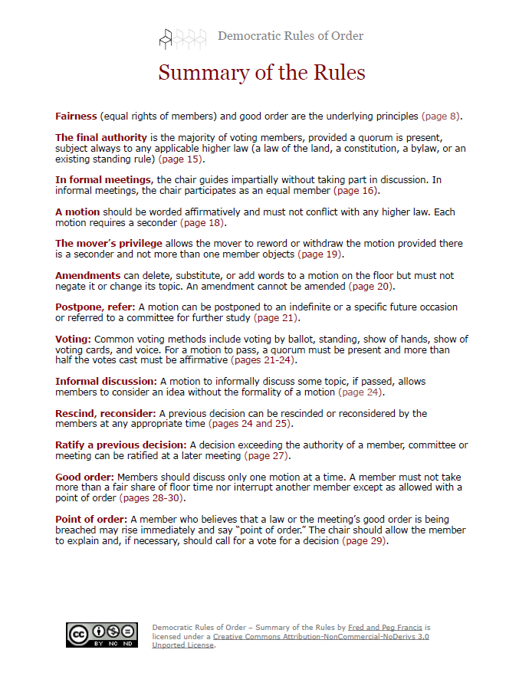

**Appendix 2**

