Select if you will be attending both days or one of the two

Add selection to cart
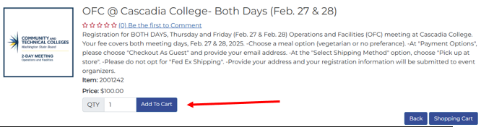
Select “No Preference” if you have no food restrictions or “Vegetarian” if you require a vegetarian option. Then select “save”
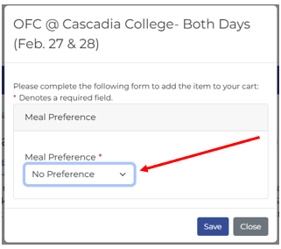

Select payment options
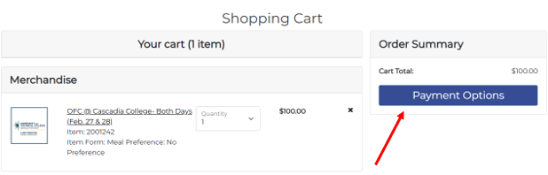
Checkout as guest by adding your email address for receipt.
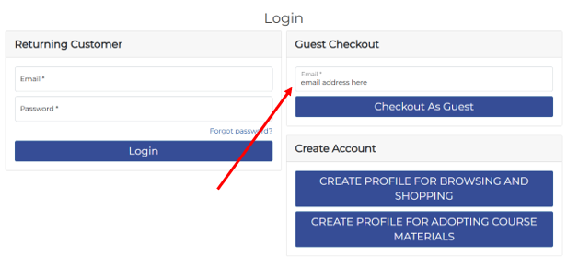
Select Pickup Order so there is no shipping charge.
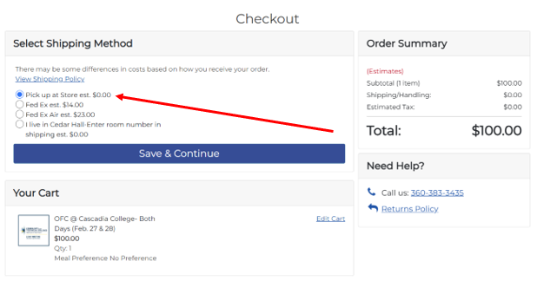
Enter campus address information.
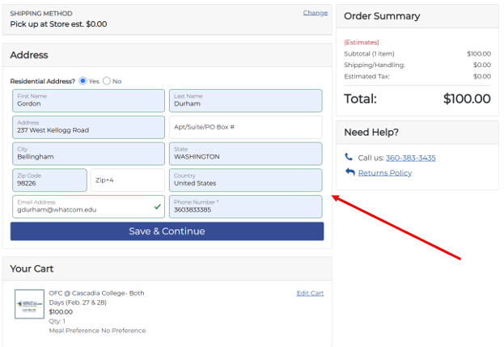
Add card information and note name/names of attendees for the registration and campus in the order comments box. This is especially helpful when admin support are registering folks using a different name/email or for those using personal cards with different names.
