

Insights Dashboards – FSCM

Contents

Overview 3

Dashboards – Phase 1 3

CTC Asset Analytics 4

CTC Year-Over-Year Asset Analytics 7

CTC Early Detection and Monitoring 9

CTC Trend Analysis 11

CTC Performance and Operations 12

Dashboards – Phase 2 14

CTC GL Financial Performance Analysis 15

CTC GL KK Budget Expense Revenue 17

CTC Grant Cost Reimbursable Award Financials 19

CTC Purchasing Operations Dashboard 21

CTC Purchasing Requisitions Dashboard 23

Dashboard Tips 24

Time Filter 24

Set the Time Filter 24

Time Filter and Fiscal Year 25

Other ways to Apply Filters 26

Inspect – Visualization Drill Down 26

Potential Issues 27

Gray Bar – Partial Data Indictor 27

Data Table Error – No Results Found 27

Dashboard is Gray and Freezes 28

Prompt Fields Show Wrong Values 29

# Overview

This document is to help with understanding the Insights Dashboards.

Insights is a Reporting and Analytics tool that allows organizations to visualize application data.  Insights provide visual reports, called visualizations, in the form of charts, tables, graphs, and more.  The data and analytics in Insights are secured by PeopleSoft PeopleTools role-based security. The security used for dashboards is not the same as query security or page security. For example, access to Asset Management queries and/or pages will not give you access to Asset Management dashboards and vice versa.

# Dashboards – Phase 1

|  |  |  |  |  |  |
| --- | --- | --- | --- | --- | --- |
| Product | Dashboard | Description | Role Needed | Companion Detail Query | Includes data not less than |
| Asset Management | CTC Asset Analytics | Analyze asset count, cost, depreciation/amortization expense, and net book value based on asset type and category. | ZD Insights AM View Privilege | QFS_INS_ASSET_ANALYTICS  Folder: INSIGHTS | Fiscal Year 2019 |
| **Data Table URL** – link to Print an Asset page | ZD Asset Management Inquiry  Or  ZZ Asset Management Reporting |
| Asset Management | CTC Year-Over-Year Asset Analytics | Analyze year-over-year comparisons of asset disposals, depreciation/amortization expense, and cost versus net book value. | ZD Insights AM View Privilege | QFS_INS_ASSET_ANALYTICS  Folder: INSIGHTS | Fiscal Year 2019 |
| Payables | CTC Early Detection and Monitoring | To view the liability and payment exposures routed through vouchers. | ZD Insights AP View Privilege | QFS_INS_VCHR_DETECT_TREND  Folder: INSIGHTS | Fiscal Year 2020 |
| **Data Table URL** – link to Voucher Summary page | ZD Accounts Payable Inquiry  Or  ZZ Quick Invoice Entry  Or  ZZ Voucher Approval |
| Payables | CTC Trend Analysis | To view the liability exposure across financial periods by summarized voucher related data. | ZD Insights AP View Privilege | QFS_INS_VCHR_DETECT_TREND  Folder: INSIGHTS | Fiscal Year 2020 |
| Travel and Expenses | CTC Performance and Operations | Analyze the travel and expense activity in a Business Unit by Operating Unit or department. | ZD Insights EX View Privilege | QFS_INS_EXPNSE_PERF_OPR  Folder: INSIGHTS | Fiscal Year 2020 |
| **Data Table URL** – link to Expense Report page (Supervisor can access expense reports for their direct reports) | ZZ PeopleSoft User |

*Please note that the* ***Date Table URL*** *provides a link to a ctcLink page to which additional role access is required. This access is not provided with dashboard access.*

## CTC Asset Analytics

Use the CTC Asset Analytics dashboard to analyze asset count, cost, depreciation/amortization expense, and net book value based on asset type and category.

The visualizations and data displayed in this dashboard are based on values selected by the **Business Unit,** **Fiscal Year,** and **Accounting Period** filters, which are required.  **Fiscal Year** and **Accounting Period** values are based on asset depreciation.

You can further filter visualizations and data based on additional filters, such as **Capitalization, Profile** (Asset Profile), and more.

**This dashboard contains the following visualizations:**

***Instructions****:* Provides instructional data specific to this dashboard.

***Asset Filters****:* Filters to refine dashboard data.

|  |  |  |  |
| --- | --- | --- | --- |
| ***Asset Count:*** Count of total assets for Fiscal Year and Accounting Period. | ***Total Cost:*** Total asset cost for Fiscal Year and Accounting Period. | ***Life to Date Depreciation:*** Life to date depreciation for Fiscal Year and Accounting Period. | ***Net Book Value:*** Total netbook value of your assets for Fiscal Year and Accounting Period. |



|  |  |
| --- | --- |
| ***Top 10 Asset Types - Asset Count:*** Top ten asset types that represent the total asset count. | ***Top 10 Categories - Asset Cost:*** The top ten asset categories with the highest asset cost. |

|  |  |
| --- | --- |
| ***Top 10 Asset Types - Asset Count by Cost Type:*** Top ten asset types by Cost Type that represent the total asset count. The stacked bar chart displays a part-to-whole comparison of Governmental Funds and Proprietary Funds. | ***Top 10 Categories - Asset Cost by Cost Type:*** Top ten asset categories by Cost Type with the highest asset cost. The stacked bar chart displays a part-to-whole comparison of Governmental Funds and Proprietary Funds. |

|  |  |
| --- | --- |
| ***Top 10 Categories - Period Depreciation/Amortization:*** Top ten asset categories with the highest depreciation/amortization expense by acquisition code. | ***Top 10 Categories - Net Book Value:*** Top ten asset categories with the highest net book value by acquisition code. |

***Top 10 Asset Types - Cost versus Net Book Value****:* Provides a side-by-side comparison of cost and net book value for each of the top ten asset types.

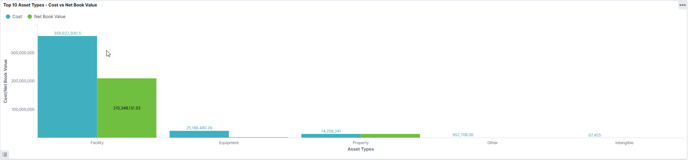

***Asset Details:*** Displays a list of assets making up the data shown in the visualizations. Use the **Asset** link to access the Printable View of Asset page and view further details about the asset.

## CTC Year-Over-Year Asset Analytics

Use the Year-Over-Year Asset Analytics dashboard to analyze year-over-year comparisons of asset disposals, depreciation/amortization expenses, and cost versus net book value.

The visualizations and data displayed in this dashboard are based on values selected for the **Business Unit** and **Fiscal Year** filters, which are required. Current and previous **Fiscal Year** values are based on asset depreciation.

You can further filter visualizations and data based on other filters, such as **Capitalization, Profile** (Asset Profile), and more.

**This dashboard contains the following visualizations:**

***Instructions****:* Provides instructional data specific to this dashboard.

***Asset Filters****:* Filters to refine dashboard data.

***Year-Over-Year Cost vs Net Book Value:*** Provides a year-over-year comparison of asset cost and net book value by accounting period. The horizontal axis represents the accounting period, and the vertical axis represents asset cost and net book value.

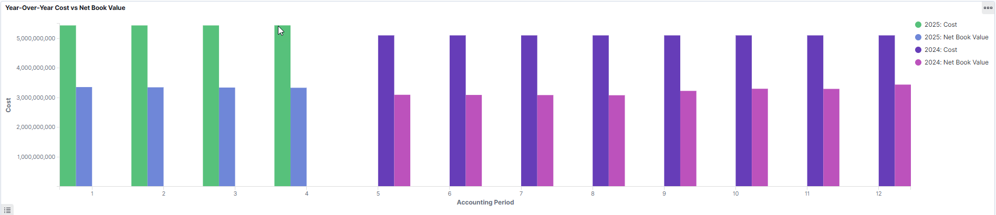

***Year-Over-Year Period Depreciation/Amortization:*** Provides a year-over-year comparison of asset depreciation and amortization by accounting period. The horizontal axis represents the accounting period, and the vertical axis represents the depreciation and amortization amount.

***Year-Over-Year Retirement Net Book Value:*** Provides a year-over-year comparison of asset retirement net book value, by accounting period. The horizontal axis represents the accounting period, and the vertical axis represents retirement gain or loss.

***Year-Over-Year Count of Retired Assets:*** Provides a year-over-year comparison of retired asset count by accounting period. The horizontal axis represents the accounting period, and the vertical axis represents retired asset count.

***Year-Over-Year Summary:*** Displays a summary of assets rolled up to Fiscal Year, Accounting Period, and Category.

## CTC Early Detection and Monitoring

The Early Detection and Monitoring dashboard provides the Accounts Payable Manager as well as the Cash Manager with a view of voucher activity.

A few examples of actions you can take with the visualizations in the dashboard:

* Apply a filter to the data (like budget status)
* Apply multiple filters (like budget status AND payment terms)
* Change the date range by using the Time Filter and Fiscal Year/Accounting Period
* Drill to view the voucher in the Document Status page
* View the visualization full screen (and minimize back to normal)

**This dashboard contains the following visualizations:**

***Instructions****:* Provides instructional data specific to this dashboard.

***Voucher Filters****:* Filters to refine dashboard data.

|  |  |
| --- | --- |
| ***Voucher Source across Month/Year Entered:***shows the number of vouchers by voucher source for a given month/year range. | ***Gross Amount by Payment Terms:***shows the gross amount by payment terms for a given time range based on the time filter and fiscal year/accounting period (if selected). |

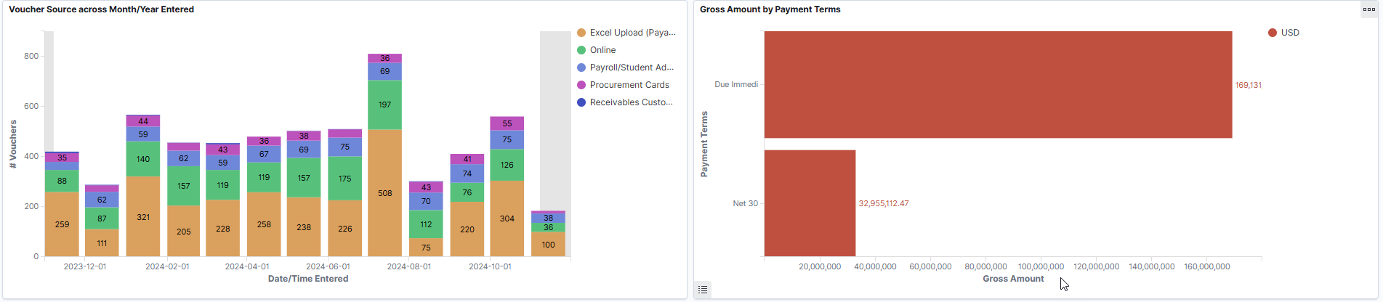

|  |  |
| --- | --- |
| ***Vouchers by Voucher Source:*** like Voucher Source across Month/Year entered managers can view the number of vouchers by source. | ***Supplier Summary:***displays the top 10 Suppliers based on gross amount. |

***Voucher Detail:*** Displays a list of vouchers making up the data shown in the visualizations. Use the **Details** link to access the Voucher Summary page to view further details about the voucher.

## CTC Trend Analysis

The Trend Analysis dashboard provides the Accounts Payable Manager as well as the Cash Manager with a period based view into liability exposure across financial periods.

**This dashboard contains the following visualizations:**

***Instructions****:* Provides instructional data specific to this dashboard.

***Filters****:* Filters to refine dashboard data.

|  |  |
| --- | --- |
| ***Gross Amounts across Year-Month Entered:*** displays the gross number of vouchers over a given period range. | ***# Vouchers by Business Unit across Year-Month Entered:*** displays the total number of vouchers by business unit over a given period range. |

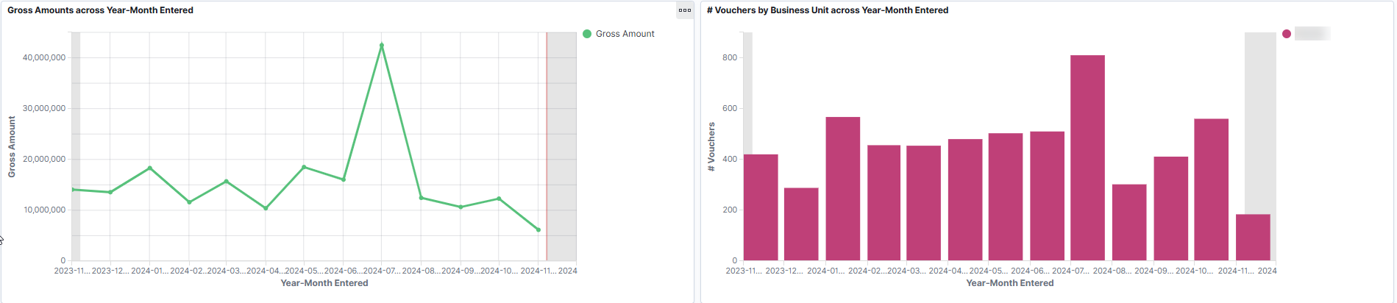

|  |  |
| --- | --- |
| ***Supplier Summary:***displays gross amount and voucher count for each Supplier. | ***Voucher Summary:***displays gross amount by voucher source, payment terms, AP post status, approval status, and budget status. |

## CTC Performance and Operations

This Dashboard can be used to analyze the travel and expense activity in a Business Unit by Operating Unit and/or department. Managers and Travel Analysts will find this helpful when reviewing expense report activities.

Please note that the supervisor associated with the employee on this dashboard is the supervisor associated with the expense report and not necessarily the same supervisor as shown in HCM.

**This dashboard contains the following visualizations:**

|  |  |
| --- | --- |
| ***Help Text:*** Provides instructional data specific to this dashboard. | ***Prompts:*** Filters to refine dashboard data. |

|  |  |
| --- | --- |
| ***Top Spenders:*** Shows employees with the highest value Expense Reports for the reporting timeframe | ***Total Activity by Expense Type:*** Shows the actual spending for various Expense Types such as Airfare, Hotels, Meals, and more within the reporting timeframe. |

|  |  |
| --- | --- |
| ***Expense Reports by Status:*** Shows the percentage of expense reports by status. | ***Expense Reports denied by Expense Type*:** Shows the percentage of expense reports denied by expense type. |

***Expense Reports:*** Displays a list of expense reports making up the data shown in the visualization. *Note: This visualization includes a “Details” link to the expense report page and will only work for employees who have the roles necessary to access the Travel and Expense pages within ctcLink.*

***Approved Expense Reports without Valid Budget Check:*** Expense reports that have been approved for payment but do not have a valid budget check status.

# Dashboards – Phase 2

|  |  |  |  |  |  |
| --- | --- | --- | --- | --- | --- |
| Product | Dashboard | Description | Role Needed | Companion Detail Query | Includes data not less than |
| General Ledger | CTC GL Financial Performance Analysis | Analyze the financial performance of a business on a yearly basis. | ZD Insights GL View Privilege | QFS_INS_GL_FINANCIAL_PRFRMNCE  Folder: INSIGHTS | Fiscal Year 2023 |
| General Ledger | CTC GL KK Budget Expense Revenue | Analyze departmental expense budgets. | ZD Insights GL View Privilege | QFS_INS_GLKK_BUD_EXP_REV  Folder: INSIGHTS | Fiscal Year 2020 |
| Grants | CTC Grant Cost Reimbursable Award Financials | Analyze the award and contract comparisons of cost, budget and billing by award, principal investigator, sponsor, project, contract type, award period, accounting year, and accounting period. | ZD Insights GM View Privilege | QFS_INS_GRNT_CST_RMBRS_AWD_FIN  Folder: INSIGHTS |  |
| **Data Table URL** – link to Award Profile | ZD Grants Read Only  Or  ZZ Awards Processing |
| Purchasing | CTC Purchasing Operations Dashboard | View the purchase order trend based on criteria such as, status, acknowledgement status, budget status, document tolerance status, and so on. | ZD Insights PO View Privilege | QFS_INS_PURCHASING_OPS  Folder: INSIGHTS |  |
| **Data Table URL** – link to Add/Update POs. | ZD Accounts Payable Inquiry  Or  ZD Purchasing Inquiry  Or  ZD Purchasing Read Only  Or  ZZ Purchase Order Entry  Or  ZZ Purchasing Approval |
| Purchasing | CTC Purchasing Requisitions Dashboard | View the requisition trend based on criteria such as, status, acknowledgement status, budget status, document tolerance status, and so on. | ZD Insights PO View Privilege | QFS_INS_PO_REQUISITIONS  Folder: INSIGHTS |  |
| **Data Table URL** – link to Requisitions – Req Inquiry page. | ZD Purchasing Read Only  Or  ZZ Requisition Entry |

*Please note that the* ***Date Table URL*** *provides a link to a ctcLink page to which additional role access is required. This access is not provided with dashboard access.*

## CTC GL Financial Performance Analysis

The CTC GL Financial Performance Analysis can be used to analyze the financial performance of a business unit on a yearly basis. You can compare the financial balances among the different fiscal years selected. You can also select an account or department for comparison. You can use the account hierarchy prompts to drill into transactions up to 5 levels for further analysis.

**This dashboard contains the following visualizations:**

***Help Text****:* Provides instructional data specific to this dashboard.

***Dashboard Prompts****:* Prompts to refine dashboard data.

|  |  |
| --- | --- |
| ***Ledger Summary:*** Displays summary information about the ledger data by the account type | ***YOY Comparison:*** Provides Year Over Year performance comparison for the selected Account Type and Fiscal Year. |

|  |  |
| --- | --- |
| ***Top 5 Expense Accounts:*** Provides details about the top performing expense accounts in each fiscal year selected. | ***Top 5 Revenue Accounts:*** Provides details about the top performing revenue accounts in each fiscal year selected. |

***Ledger Details:*** Displays details about the ledger data selected on the dashboard in tabular format in sections divided by the account type*.*

## CTC GL KK Budget Expense Revenue

The CTC GL KK Budget Expense Revenue dashboard can be used to analyze departmental expense budgets. The intended user for this dashboard is someone who is responsible for departmental budgets. You can use the account hierarchy prompts to drill into transactions up to 5 levels for further analysis.

This dashboard combines data from General Ledger and Commitment Control. Budget, Encumbrance and Pre-Encumbrance data come from Commitment Control which is designated within the visualization with the column heading followed by (KK). Expenses and Revenue data come from General Ledger which is designated within the visualization with the column heading followed by (GL).

**This dashboard contains the following visualizations:**

***Help Text****:* Provides instructional data specific to this dashboard.

***Prompts****:* Filters to refine dashboard data.

***Total Amounts****:* Amount totals based on the prompted fiscal year and accounting periods (if selected).

|  |  |
| --- | --- |
| ***Expense Accounts by Summary Budget:*** Shows budget from CC_SUM_BUD ledger and expenses from GL ledger. | ***Expense Accounts by Detail Budget:*** Shows budget from CC_ORG_BUD ledger and expenses from GL ledger. |

***Actual Expense by Accounting Period:***Shows expenses by fiscal year and accounting period.

***Revenue Summary Data Table****:* General Ledger revenue data by account code.

***Top 5 Department Detail Budgets****:* Departments with the top 5 budgets from CC_ORG_BUD ledger.

***Expense Summary by Rollup Data Table:***GL expense data by expense roll-up accounts.

***Expense Detail (amount not equal 0) Data Table****:* GL expense data detail.

## CTC Grant Cost Reimbursable Award Financials

The CTC Grant Cost Reimbursable Award Financials dashboard can be used to analyze the award and contract comparisons of cost, budget and billing by award, principal investigator, sponsor, project, contract type, award period, accounting year, and accounting period.

Filters are defaulted based on the user's project preferences. The Award PI (example: principal investigator) defaults to the user logged in and using the dashboard making the assumption that the user is the Principal Investigator. The Award End Date defaults to the current day plus ten years as a means of determining the active awards.

**This dashboard contains the following visualizations:**

***Help Text****:* Provides instructional data specific to this dashboard.

***Prompts****:* Filters to refine dashboard data.

|  |  |
| --- | --- |
| ***Award Summary:*** Summary of the top awards for the business unit. | ***Cost by Award:*** Top 10 awards by expense and budget. |

|  |  |
| --- | --- |
| ***Billing by Sponsor:*** Top 10 sponsors by billing. | ***Billing by Project:*** Top 10 projects showing breakdown by amount categories. |

|  |  |
| --- | --- |
| ***Cost by Principal Investigator:*** Top 10 principal investigators by cost. | ***Award Summary by Award Period:*** Displays a list of awards details including Award Period, Actual Cost, Budget, and Billing. |

***Cost and Billing by Year and Period****:* Expense, billed and billable amounts by year and period.

***Award Financials by Fiscal Year and Period****:* Displays a list of awards based on Award Period, Fiscal Year, and Accounting Period. Click the **Drill to Award** link to navigate to the Award - Award Page.

## CTC Purchasing Operations Dashboard

The CTC Purchasing Operations Dashboard can be used to view the purchase order trend based on criteria such as, status, acknowledgement status, budget status, document tolerance status, and so on.

This dashboard helps buyers to analyze the current trend of purchase orders. You can apply different filters to modify data across all visualizations. Hover over different sections in the visualization to see the detailed statistics.

**This dashboard contains the following visualizations:**

|  |  |
| --- | --- |
| ***Help Text:*** Provides instructional data specific to this dashboard. | ***Prompts:*** Filters to refine dashboard data. |

|  |  |
| --- | --- |
| ***Purchase Orders by PO Status:*** Shows the number of purchase orders by their statuses. | ***Purchase Orders by Budget Status:*** Shows the number of purchase orders by their budget status. |

|  |  |
| --- | --- |
| ***Pending and Past Due Deliveries:*** Shows the number of purchase orders that are pending or past their delivery due date. The Pending bar represents the purchase orders that are open either partially or fully, but with a due date in the future. The Past Due bar represents those schedules that are either not yet received or partially received, and past the due date. | ***Purchase Orders by Period:*** Shows the number of purchase orders created over a time period based on the purchase order date. |

***Purchase Order Details****:* Displays a list of purchase orders and related details. Click the **View PO** link of a purchase order to view or modify its details.

## CTC Purchasing Requisitions Dashboard

The CTC Purchasing Requisitions Dashboard can be used to view the requisition trend based on criteria such as, requisition status, budget status, PO status, and so on.

This dashboard helps buyers to analyze the current trend of requisitions. You can apply different filters to modify data across all visualizations. Hover over different sections in the visualization to see the detailed statistics.

**This dashboard contains the following visualizations:**

|  |  |
| --- | --- |
| ***Help Text:*** Provides instructional data specific to this dashboard. | ***Prompts:*** Filters to refine dashboard data. |

|  |  |
| --- | --- |
| ***Requisitions by Req Status:*** Shows the number of requisitions by their statuses. | ***Requisitions by Budget Status:*** Shows the number of requisitions by their budget status. |

|  |  |
| --- | --- |
| ***Requisition Data****:* Displays a list of requisitions and related details. Click the **View Req** link of a requisition to view its details. | ***Requisition Count by Period:*** Shows the number of requisitions created over a time period based on the date the requisition was entered into the system. |

# Dashboard Tips

## Time Filter

The time filter displays data within a specified time range. The most common time range will start with the current date and then go back in time for the specified range. The time filter will bring in all data for the specified time range. For example, if the time filter is set to **Last 3 years** this means that the data displayed on the dashboard is from 3 years ago up to the current date.





Some dashboards will include additional time related filters in the dashboard filter section. These time related filters, such as fiscal year and accounting periods, can be used to further refine the data to specific time periods.

## Set the Time Filter

To populate the dashboard with data you must first update the time filter which is found at the top right side of the dashboard. The time filter defaults to **Last 15 minutes** each time the dashboard is opened.

Click on the calendar icon  to open the **Quick select** pop-up (shown below). Hover to the right of number **15** toward the word **minutes** until you get the double arrow icon. Change the **15** to **2**. Click on the drop-down to the right of **minutes**. Select **years.** Click the **Apply** button. You have now set the time filter to **2 years**.

## Time Filter and Fiscal Year

As indicated above, the time filter is based on a calendar year starting with the current date and going back from that point. When a dashboard filter section includes a fiscal year filter, it will be important to set the time filter to bring in all the data for the fiscal year.

For example, you want to see all the data for fiscal year 2024 but we are in the 2nd accounting period of fiscal year 2025. You should set the time filter for 2 years of data and then select 2024 from the fiscal year filter.

|  |  |  |
| --- | --- | --- |
|  | Fiscal Year | Time Filter |
| 2025 | 1 year |
| 2024 | 2 years |
| 2023 | 3 years |
| 2022 | 4 years |
| 2021 | 5 years |
| 2020 | 6 years |

A good rule of thumb is to add one year to the time filter for each prior fiscal year you want to review.

## Other ways to Apply Filters

There are several ways to apply filters; the easiest is to select what you are interested in.  In some cases, what you have selected represents more than one filter; and in this case you can select / unselect from a list before applying the filter(s).

When the green section of the bar above is selected it represents two filters, entered date/time and voucher source.

The list of the 2 filters is presented as selected:

Select **Apply** to add both filters – a filter on entered date/time and a filter on voucher source; or unselect for just one filter.

To reset the dashboard to the previous settings, reset the time filter and the dashboard filters.

## Inspect – Visualization Drill Down

Each visualization can be viewed separately on a full screen. You can also drill down for more information using the **Inspect** option. That data can be downloaded as a comma separated value (CSV) file.

Hover your cursor over the right hand upper corner of the visualization. image. You will see the following pop-up. Click on **Inspect** drill down for more information. Click on **Maximize panel** to view the visualization as a full screen.

# Potential Issues

## Gray Bar – Partial Data Indictor

|  |  |
| --- | --- |
| If a bar chart includes a gray bar, this indicates that only a portion of the data for that time-period has been included.  When you hover over the gray bar, the following message will appear, “This area may contain partial data. The selected time range does not fully cover it.”  Adjust the time filter at the top of the dashboard to include more data. |  |

## Data Table Error – No Results Found

This error will occur when there is too much data for the data table to display. Adjust the time filter to bring in less data into the dashboard. The best option is to set the time filter to 1 year unless working with a multiple year dashboard such as Year-Over-Year or Trend Analysis.

## Dashboard is Gray and Freezes

The dashboard freezes and charts only display gray color. Filter will show a “disabled” message when the mouse is hovered over the filter.

Try the following steps to reactivate the dashboard. **Be sure to load only 1 years’ worth of data to the time filter.**

|  |  |
| --- | --- |
|  | Step 1 - Reload the webpage by clicking on the “Reload this page” indicator.  If that doesn’t work … |
|  | Step 2 – Return to your homepage, wait for the dashboard tile reload then click on the tile to go back to the dashboard. |

## Prompt Fields Show Wrong Values

The Business Unit prompt dropdown shows the wrong business unit.

This can be caused when the cache has not cleared correctly.

Click in the circling arrow in the upper left corner of the browser. This will refresh the page.

This will reload the data being used by the page which should refresh the prompt values.