

ctcLink PeopleSoft query Development Life Cycle (QDLC)

Paula McDaniel

SBCTC Data Services Reporting Team

| Revisions |  |
| --- | --- |
| Change reference | Date |
| Original Version | 07/2019 |
| Updated Standards | 09/2022 |
| Updated Standards | 08/2023 |
| Updated Definition Template <BR> | 02/2024 |
| Added FTI Standard | 07/2024 |
| Added Apply Data Protection Flag content | 09/2024 |
| Population Selection Naming/Folder | 03/2025 |
| Migration Authorization Approval Process Updates | 07/2025 |

Table of Contents

Revisions 1

Course Goal 5

Course Learning Objectives 5

Query Developer Structure and Query Manager Access Levels 6

Query Developer Structure 6

The Reporting Lead 6

Query Developer Levels and Query Manager Access 6

ctcLink PeopleSoft PCD Query Development Life Cycle 4

ctcLink PeopleSoft Query Development Lifecycle PCD 4

QDLC Summary 6

PHASE I: Query Development 7

Requirements for Query Manager Access in PCD 7

Search for Existing Queries or Reports before Developing New Queries 7

Develop a New Query in PCD Environment 8

FERPA (Family Educational Rights and Privacy Act) and the Name Field 9

CTC_DATA_PROTECT and the Name Field 9

FTI (Federal Tax Information) 9

Data Dump Queries 9

Finding Records to Use in Query Development 11

Naming Conventions 12

Module Acronyms and Names 13

Query Description 14

Query Definition 14

Prompts 16

Public not Private Queries 17

Query Organization – Folders and Favorites 17

Test the Query 17

Performance Standards 18

College-Specific Queries 18

PHASE II: Submit a Migration Request 21

PHASE III: Migration to Production 23

Query Migration Schedule 23

PHASE IV: Modification of Existing Queries 24

Modifying Queries Created by Others 24

Other Reporting Tools Development Conventions and Protocol 26

Population Selection Conventions and Protocol 26

Population Selection Description 27

Population Selection Definition 27

Population Selection Folder 27

CEDQ Conventions and Protocol 27

CEDQ Naming Convention 28

CEDQ Description 28

CEDQ Definition 28

CEDQ Folder 28

• Queries that use a BIND record that are not CEDQ data sources should be stored in the POPULATION SELECT folder. 28

• Queries that use a BIND record that are CEDQ data sources should be stored in the COMMUNICATIONS folder. 29

BI Publisher Conventions and Protocol 29

BI Publisher Naming Convention 30

BI Publisher Description 30

BI Publisher Definition 30

BI Publisher folder 30

BI Publisher Data Sources 30

BI Publisher Data Source Conventions 30

PS Queries for BI Publisher 31

Connected Queries for BI Publisher 31

Composite Queries for BI Publisher 31

Pivot Grid Conventions and Protocol 32

Pivot Grid Naming Convention 32

Pivot Grid Description 32

Pivot Grid Definition 32

Pivot Grid Folder 33

Pivot Grid Data Sources 33

Pivot Grid Data Source Conventions 33

PS Queries for Pivot Grid 33

Composite Queries for Pivot Grid 34

Components for Pivot Grid 34

nVision Conventions and Protocol 35

nVision Naming Convention 35

NVision Description 35

NVision Definition 36

NVision Folder 36

nVision Data Sources 36

nVision Data Source Conventions 36

PS Queries for nVision 36

Ledgers and Trees for nVision 37

Connected Queries 38

Connected Query Conventions Overview 38

Connected Query Conventions and Protocol 39

Connected Query Parent and Child Queries Conventions 41

Parent Query Naming Convention 41

Parent Query Description 41

Parent Query Definition 41

Child Query Naming Convention 41

Child Query Description 42

Child Query Definition 42

Composite Queries 43

Composite Query Conventions Overview 43

Composite Query Conventions and Protocol 44

Composite Query Base Queries 45

Composite Base Query Naming Convention 45

Composite Base Query Description 46

Composite Base Query Definition 46

Who Owns What Queries and Reports? 47

Queries 47

Financial Aid Queries 47

Reports 48

Query Maintenance 48

Links Provided in this Document 49

# Course Goal

The goal of this course is to train Query Developers on the relationship between training and Query Manager access levels and the conventions and protocols followed in the Query Development Life Cycle. This will allow for quick and efficient query migration of new and updated queries from the Production College Development (PCD) environment to the Production (PRD) environment.

# Course Learning Objectives

At the end of this course users will be able to:

1. Define roles, responsibilities and requirements for each Query Developer level.
2. Explain why searching for an existing query before developing a new query is the essential first step in query development.
3. Describe query development conventions and protocol in query creation and modification. Including:
   1. Query Naming Convention
   2. Query Description
   3. Query Definition
   4. Prompts Utilization
   5. Public vs Private Queries
   6. Query Folders
   7. Query Performance
4. Demonstrate the ability to correctly fill out a Query Migration Request Form.
5. Identify all criteria which must be met to modify an existing query.
6. Identify who owns what Query or Report based on prefix.
7. Explain BI Publisher reports naming convention
8. Explain Pivot Grid naming convention
9. Explain nVision naming convention
10. Explain Connected Query naming convention
11. Explain Composite Query naming convention

# Query Developer Structure and Query Manager Access Levels

This document is designed to provide users with knowledge of Query Developer and advancement. Successful completion of training is closely related to the level of access a user has. As more and more training is successfully completed the user is able to gain more access to Query Manager as well as access to other reporting tools such as Pivot Grid and Composite Query. At the end of this section users will be able to:

* Explain Query Developer structure, roles and responsibilities of each role.
* Define the steps that must be successfully completed in order to acquire access to Query Manager.
* Define the steps that must be successfully completed in order to become an Advanced Query Developer or Report Developer.

## Query Developer Structure

There is a definitive structure that each institution will follow for managing query development and Query Developers. Each institution will have:

* A Reporting Lead
* PS Query Developers

Each institution may have:

* Advanced PS Query Developers
* Report Developers

### The Reporting Lead

Each institution will have a person designated as a Reporting Lead. This person will:

* Be the main point of contact for SBCTC relating to query development.
* Authorizes which college staff are designated query developers.
* Set up and follow an internal process that ensures all query development and/or modification requests from their college are first sent to the query developers at their institution. If the query is not able to be developed or modified by the college query developer team then the college query development staff will submit the request to the State Board, not the end user.
* Enforces the query development life cycle with their query developers.
* Serves as an active member of the Query Governance group by attending monthly meetings and other duties as needed.
* Address query development training needs.
* Have a high-level understanding of query security.
* Manage yearly query validation and archive process for their college.
* Assume responsibility for maintaining each of their college specific queries.

Though there may be some colleges who wish to designate an internal lead per pillar, or designated co-leads, there will need to be a single “main” reporting lead for SBCTC purposes.

### Query Developer Levels and Query Manager Access

As Data services manages Query Developer training and access to Query Manager, it is our goal that all Query Developers are granted the correct access to fit their ability. As their ability and skills grow, their access to Query Manager can expand concurrently.

There are currently three levels of Query Developers:

* Query Developer
* Advanced Query Developer
* Report Developer

#### Query Developer

* Access to Query Manager in the PCD (Production College Development) environment only.
* Access to records and pillars is dependent on job function and security.
* Limited to creating only up to 6 joins in a single query.
* Follows the Query Development Life Cycle (QDLC) standards.
* Liaison between college report requester and the SBCTC ctcLink Reporting Team.
* Understands and uses query search tools prior to submitting requests.
* Requires passing the following courses with an assessment score of 80% or higher in each course.
  + QDLC
  + 101 Basics
  + 102 Security
  + 201 Intermediate
  + 301 Advanced
  + 302 Migrations
* Submits a Non-Disclosure Agreement signed by the Reporting Lead.
* Courses are competency based and may be passed by only completing the assessments successfully, if desired.

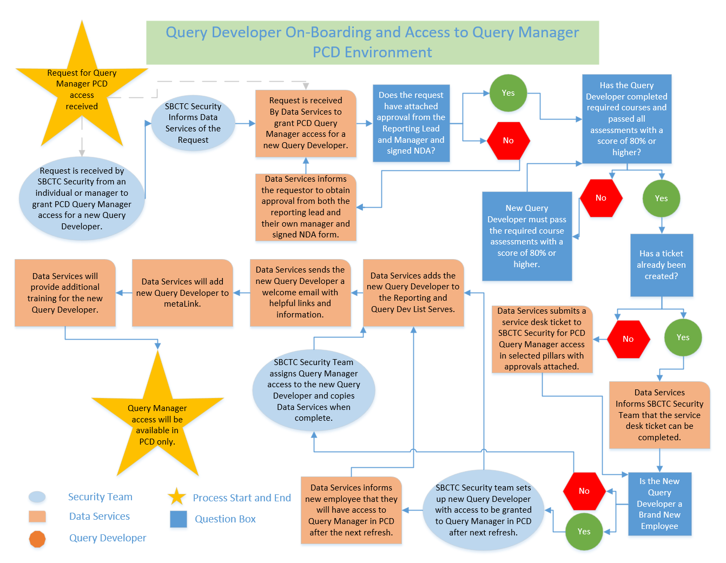New Query Developers will need to follow the subsequent process to be given access to Query Manager in PCD:

#### Advanced Query Developer

* Access to Query Manager in PCD.
* Access to records and pillars is dependent on job function and security.
* No limit on the number of joins used in a single Query.
* Follows the Query Development Life Cycle (QDLC) standards.
* Liaison between college report requester and the SBCTC ctcLink Reporting Team.
* Understands and uses query search tools prior to submitting requests.
* Requires passing PS Query 101, 201, 301, 302, 401 and QDLC training with an assessment score of 80% or higher for each course.
* Submits a Non-Disclosure Agreement signed by the Reporting Lead.
* Courses are competency based and may be passed by only completing the assessments successfully, if desired.

Query Developers will need to follow the subsequent process to be designated an Advanced Query Developer: 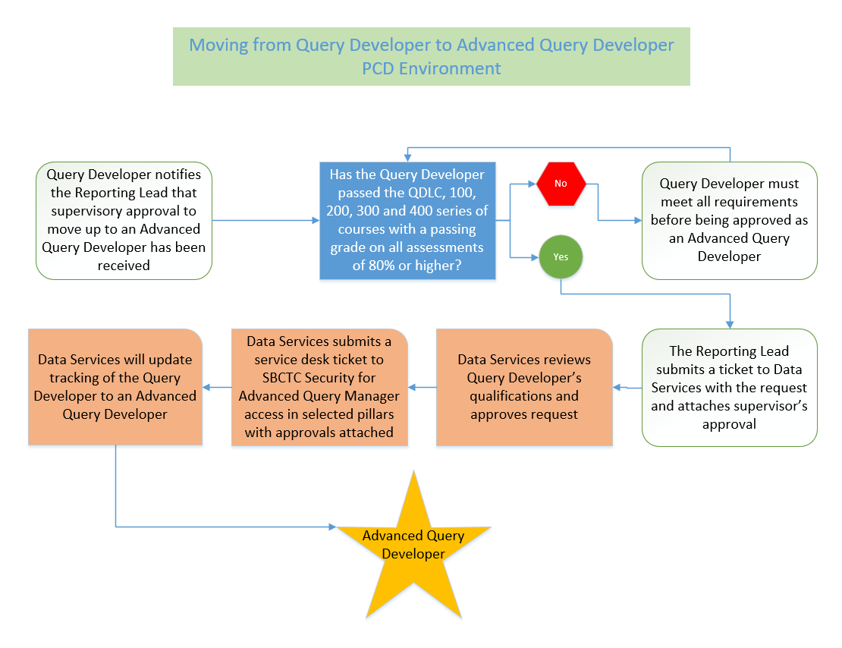

#### Report Developer

Report developers enjoy all of the same benefits and access levels as Advanced Query Developers with the addition of access to Pivot Grid or Composite Query for true report development.

* Access to Query Manager in PCD.
* Access to records and pillars is dependent on job function and security.
* No limit on the number of joins used in a single Query.
* Follows the Query Development Life Cycle (QDLC) standards.
* Liaison between college report requester and the SBCTC ctcLink Reporting Team.
* Understands and uses query search tools prior to submitting requests.
* Access to Pivot Grid or Composite Query.
* Must be an Advanced Query Developer as well as pass the Pivot Grid 101 training with an assessment score of 80% or higher.
* Courses are competency based and may be passed by only completing the assessments successfully, if desired.

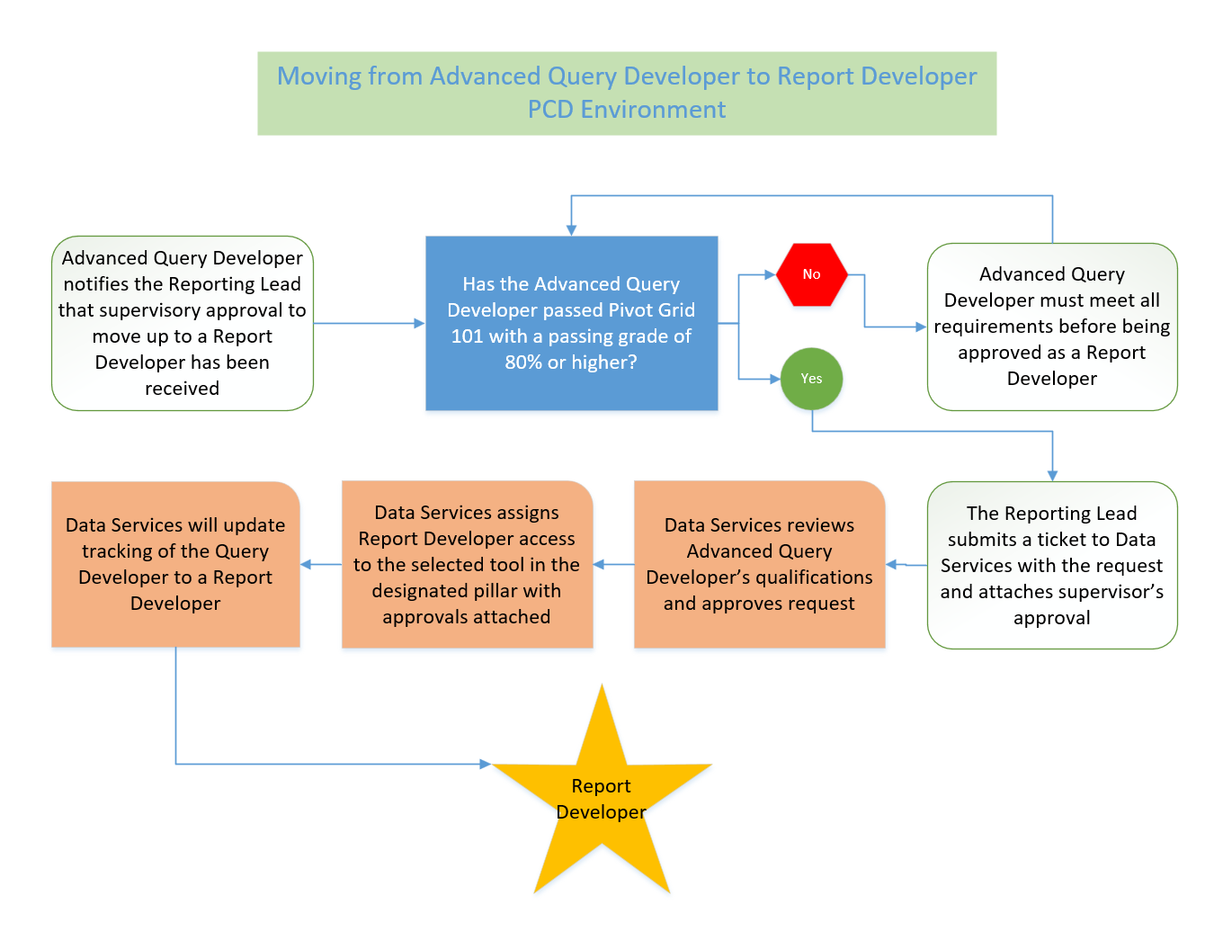Advanced Query Developers will need to follow the subsequent process to be granted Report Developer access to Query Manager in PCD.

# ctcLink PeopleSoft PCD Query Development Life Cycle

This section is designed to instruct users on the correct protocol and conventions to follow when creating a query in the PCD environment. Section 2 covers in detail the Query Development Life Cycle and each phase of query development. At the end of this section users will be able to:

* Describe the 4 phases of the Query Development Lifecycle.
* Detail how FA queries are treated differently than other queries.
* Describe the benefits of searching for queries using metaLink.
* Define the methods used to find records and fields to be used in query development.
* Describe query development conventions and protocol in query creation and modification. Including:
  + Query Naming Convention
  + Query Description
  + Query Definition
  + Prompts Utilization
  + Public vs Private Queries
  + Query Folders
  + Query Performance
* Define the purpose of the Query Migration Request Form
* List what possible modifications may be made to an existing query and the steps a Query Developer must take before modifying any existing query.
* Explain why delivered queries should never be modified.

# ctcLink PeopleSoft Query Development Lifecycle PCD

Queries written in PeopleSoft Query should be written in the Production College Development (PCD) environment. This means that for a query to be used in the Production environment (PRD), it must first be copied to PRD from PCD. This process is known as query migration. All queries will first be written in PCD and then migrated to PRD. Queries are migrated on Tuesdays and Thursdays.

There are four phases of query development.

* Phase I – Query Development in PCD
  + Search for existing queries that may meet the need first before developing a new query.
  + Always follow the correct protocol and conventions when developing a new query.
  + Test the query thoroughly for accurate results.
  + Note: All Financial Aid queries, whether new or modifications, require approval from the SBCTC (State Board for Community and Technical Colleges) Financial Aid Support Team.
* Phase II – Request migration of the query from PCD to PRD.
  + Queries written in PeopleSoft Query are written in the Production College Development (PCD) environment. This means that for a query to be used in the Production environment (PRD), it must first be copied to PRD from PCD. This process is known as query migration. Queries are migrated on Tuesdays and Thursdays.
* Phase III – The query is reviewed for compliance with query standards and the Data Services Reporting Team does an advanced review of the query. It is then migrated to PRD.
  + This review process ensures consistency in query development.
* Phase IV – Optional Phase that pertains to modifying queries that already exist in Production.
  + There are only two modification types generally always allowed:
    - Adding an optional prompt to an existing query.
    - Adding an additional field that does NOT result in row duplication.
  + Other modifications may be allowed on a case-by-case basis.
  + All modifications require approval.
  + Note: All Financial Aid queries, including modifications, require approval from the SBCTC Financial Aid Support Team.
  + Modifications must be done in PCD and then migrated to PRD. Modifications of existing queries are not allowed in PRD.

### QDLC Summary

Below is a summary depiction of the ctcLink Query Development Life Cycle (QDLC).

* Search for an existing query or report. If needed, develop in PCD environment.
* Use the standard naming convention.
* Add a description and full definition to query properties.
* Add prompts whenever possible instead of hard coding criteria.
* Make the query public.
* Store in a logical folder.
* Test the Query for accuracy, performance and data validation.
* Submit a Service Desk ticket to migrate the query to Production.
* Include a completed Query Migration Request form (QMRF) with the ticket ensuring the query passes all requirements.
* The query will be tested for compliance and functionality and an advanced review will be performed by the Data Services Reporting Team.
* Data Services submits migration request to the hosting service.
* The query will be added to View Query Search Listing in metaLink.
* For access to metaLink please email: [*dataservices@sbctc.edu*](mailto:dataservices@sbctc.edu).
* **Do not save over the original query**, instead create a DEV_ version.
* Understand how a modification will impact the original purpose.
* Determine if a modification is acceptable, or if a new query needs to be developed. If modifying an existing query, make a DEV_ copy first.
* Get approval from the original Query writer, if possible. If not, follow the standards outlined in Phase IV for whom to contact for authorization.
* Repeat QDLC starting at the second step of Phase I.
* If desired, request that the original query be removed from PRD.

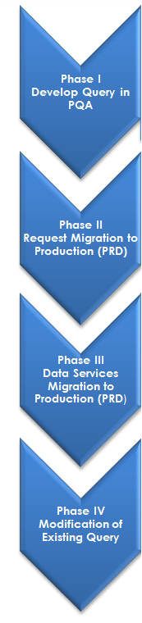

**PCD**

## PHASE I: Query Development

### Requirements for Query Manager Access in PCD

The document [Structure for Query Manager Access](https://www.sbctc.edu/resources/documents/colleges-staff/data-services/peoplesoft-ctclink/structure-for-query-manager-access.pdf) discusses all the requirements for access to Query Manager in PCD in more detail; however, the basic requirements to gain access to Query Manager in PCD is to turn in a signed Non-Disclosure Agreement as well as complete both the PeopleSoft Query 101 Basics course as well as the QDLC course.

#### Non-Disclosure Agreement

A security measure initiated by Data Services is the Non-Disclosure Agreement (NDA). Each Query Developer must sign this document and have their Reporting Lead sign it as well. If a signed NDA is not received by Data Services, access to Query Manager in PCD will not be granted. Once signed (electronic signatures are acceptable), return it to Paula McDaniel at [pmcdaniel@sbctc.edu](mailto:pmcdaniel@sbctc.edu) or [dataservices@sbctc.edu](mailto:dataservices@sbctc.edu). The NDA form is also used for dataLink Developers. If a person is both a dataLink Developer and a Query Developer, only one form is required. Either the Reporting Lead or the IT Director must sign the form, not both.

#### Required Courses for Access to Query Manager

Query Developers must pass the final assessments for the Query Development Life Cycle (QDLC) course as well as the ctcLink PeopleSoft Query 101 Basics course with a score of 80% or better. These are competency-based courses, so it is only necessary to complete the final assessments successfully to pass the courses.

### Search for Existing Queries or Reports before Developing New Queries

* Better to use an existing query than develop a new one.
* Minimizes query clutter.
* Easier to find needed query since there are fewer to look through.
* Query is already in production, so it reduces wait time for the end-user.

Always search existing queries or reports before creating a new query. This can potentially save a large amount of time and resources. If a query is found that is close, a Query Developer can use it as the foundation for a new query by using “Save As”. (See Phase IV of the QDLC) There are many existing queries, so it is likely a usable query has already been developed. **Note: All FA queries, whether new or modified, must first be approved by the SBCTC Financial Aid Support Team.**

While we will be learning *how* to search in the PeopleSoft Query 101 Basics course for developers and the Reporting Course for end users, it is important to note that there are various methods for searching for queries—either in PeopleSoft or in metaLink.

#### PeopleSoft Query Basic Search

Search using the operator “Begins With” by multiple search criteria including:

* Access Group Name
* Description
* Folder Name
* Owner
* Query Name
* Type
* Uses Field Name
* Uses Record Name

#### PeopleSoft Query Advanced Search

Search using the same search criteria as the basic search but with the choice of the following operators:

* <
* <=
* =
* >
* >=
* Begins With
* Between
* Contains
* In
* Not =

#### Searching for Queries within metaLink

metaLink is a data dictionary provided by Data Services where users can also search for queries, reports, and pivot grids. metaLink offers the benefit of being able to search for queries based on the Definition Field (Long Description), which has no character limit but is not available to see in Query Viewer. Query Viewer only displays the Description field, which is limited to 30 characters, so being able to search on the Definition field is a major benefit to performing query searches using metaLink. Users can also use metaLink to search for both field and record metadata to gain valuable insight into the data structure. Using metaLink is covered in the PeopleSoft Query 201 Intermediate course or in the stand-alone course How to Use metaLink.

The key features of metaLink allow designated users to:

* + Document structures and properties for a given record or field
  + Track and record changes by user, date, and what was changed
  + View the ctcLink reporting catalog
  + Search for available queries, reports, and pivot grids
  + View data dictionary reports (requires a password)
    - Please submit all requests for metaLink passwords to: [dataservices@sbctc.edu](mailto:dataservices@sbctc.edu)

### Develop a New Query in PCD Environment

PCD contains the three pillar instances: Campus Solutions (CS), Finance (FIN), and Human Capital Management (HCM). Designated Query Developers develop queries in the PCD environment, not in the PRD environment. This ensures that the queries in PRD have been tested, meet standards, and do not affect PRD performance. Why are queries not developed in PDV? Because Query Developers are developing queries, not views, tables, pages, or procedures. Developing queries in PCD is acceptable and reduces the development time by eliminating one migration request step. The PDV environment is also refreshed at a slower rate than the PCD environment.

Some developers prefer to store their draft queries in a personal folder. This is allowed, but just make sure that the query has been added to the correct folder prior to requesting migration. Data Services maintains a list of allowed folder names in the [Query Folder List per Pillar](https://www.sbctc.edu/resources/documents/colleges-staff/data-services/peoplesoft-ctclink/pillar-folder-lists.pdf) document. Folder names are free text and are automatically migrated with the query.

The PCD environment is typically refreshed on the first Monday of every month from PRD. The environment is available for use Monday – Friday from 7 am to 7 pm.

### FERPA (Family Educational Rights and Privacy Act) and the Name Field

When displaying a student name in query results, in the CS pillar it is required to add the field FERPA_BLOCK to the query results as well. It must follow directly after the Name field. To do this, the Query Developer adds the student's name to the query using either the view VCS_BIO_PRIORTY or VCS_BIO_PRIMARY. No other record or view is allowed for this purpose. The VCS_BIO_PRIORTY view will prioritize the preferred name, over the primary name, if it is available, while the VCS_BIO_PRIMARY view will prioritize the primary name, over the preferred name, if it is available. A process is in place to ensure that every student has a primary name, at a minimum.

### CTC_DATA_PROTECT and the Name Field

The “Apply Data Protection” flag will protect all employees across the system who have asked not to have personal information shared. In the same way that FERPA_BLOCK protects our students, CTC_DATA_PROTECT must directly follow any Name field that pertains to a system employee in HCM queries. It must be used for both Primary and Preferred Name, though it is only required for Primary Name if both name types are used in the same query, as both names are for the same EMPLID. The field is found in the VHC_PERSON_DATA view. The heading for the query must be RFT Long so the full title of Apply Data Protection is shown in the query results. VHC_PERSON_DATA should be the only record used to display a system employee name in a query.

### FTI (Federal Tax Information)

Queries that populate Federal Tax Information (FTI) data will need to have the CUI//SP-TAX labeling. Any field(s) that contain FTI data:

* Will contain FTIM somewhere in the field name.
* Must all be grouped together in the query results with no other fields in between.
* The field or group of fields must be:
  + Proceeded by the SFA_STD_FTIM_FTI - FTI label start field
  + Followed by the SFA_OTH_FTIM_FTI - FTI label end field

The field grouping (including the label start and label end) can be anywhere in the query results and other fields can proceed or follow the grouping.

These views hold the required Label Start and Label End fields:

* VCS_ISIR_00_2_S
* VCS_SFAFANFTI_S
* VCS_SIM_ISIRC_S
* VCS_SFAISIRCT_S

There is a custom field found in two custom views that does not contain FTIM in its name that also contain FTI data and has the same requirements as the FTIM fields:

* Field - CTC_SNG_INCOME
  + Custom View - CTC_SNG_ELG_TBL
  + Custom View - CTC_SNG_ELG_VW

### Data Dump Queries

Data dump queries may be useful to Query Developers for studying record details or to developers or end users to use for data analysis. We recommend data dump queries in the Production College Development (PCD) environment for studying record details and in Production (PRD) for data analysis.

There are many existing data dump queries. They will contain “data dump” in the query description. Data dump queries in PRD may also be requested. Please see [Data Dump Query Protocol](https://www.sbctc.edu/resources/documents/colleges-staff/data-services/peoplesoft-ctclink/data-dump-queries.pdf) for more information.

### Finding Records to Use in Query Development

One of the most challenging steps in developing a query, especially for those new to PeopleSoft, is to determine which table (record) contains the data needed. Query Developers use records and views to create new queries. A record is a delivered table, and a view is one created by Data Services.

#### Commonly Used Tables

Find common records and views to use by pillar in the following spreadsheets:

* [Campus Solutions Commonly Used Tables](https://www.sbctc.edu/resources/documents/colleges-staff/data-services/peoplesoft-ctclink/cs-common-tables-for-reporting.xlsx)
* [Finance Commonly Used Tables](https://www.sbctc.edu/resources/documents/colleges-staff/data-services/peoplesoft-ctclink/fin-common-tables-for-reporting.xlsx)
* [Human Capital Management Commonly Used Tables](https://www.sbctc.edu/resources/documents/colleges-staff/data-services/peoplesoft-ctclink/hcm-common-tables-for-reporting.xlsx)

We will learn the steps for using shortcut keys/extensions to find record and field information in the ctcLink [PeopleSoft Query 201 Intermediate](https://sbctc.instructure.com/enroll/DMWB7K) course, however, the shortcut keys and extensions are included here as a reference for the correct processes to follow for finding the records and fields, which are being written to from a particular front end page.

#### CTRL + SHIFT + J

One trick to determining the record is to first locate the PeopleSoft page where the data is entered. While on that page, use the keystrokes CTRL + SHIFT + J. This will bring up a new page that lists the technical page name. This functionality is not available in the PRD environment.

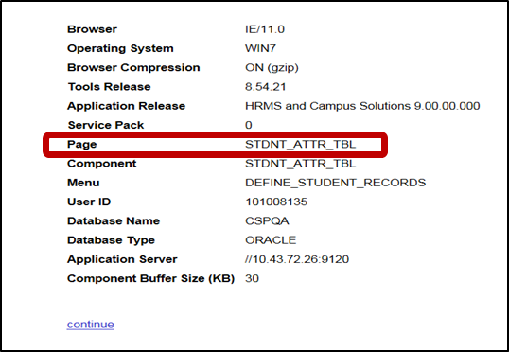

Next, run the query QXX_PSPNLFIELD where XX is the pillar acronym. The query will prompt for the page name. The query will then return each field shown on the page and the corresponding record and field names.

#### CTRL + SHIFT + C

Another method of finding record and field information is to use CTRL + SHIFT + C. Use a mouse to hover over the field to see the field and record name. This tool is not available in Internet Explorer.

#### PSChrome Extension

Also consider downloading the PSChrome Extension. It is available to search for at: <https://google.com/chrome/webstore> Search for “PeopleSoft” in the search bar and then download PSChrome. The extension allows for searching page information and field information from any PeopleSoft screen.

#### metaLink

metaLink is the data dictionary provided by Data Services. Search record and field information using the data dictionary reports. A password is required to access the data dictionary reports. Please submit all requests for metaLink passwords to: [dataservices@sbctc.edu](mailto:dataservices@sbctc.edu). For more information on metaLink view the course [How to Use metaLink](https://sbctc.instructure.com/enroll/NRJMYK).

### Naming Conventions

* QXX_XX_XXXXXXXX
* Q for Query or V for View Pillar Abbreviation_Module Abbreviation_Description
* QCS_AA_ENROLLED_NO_ADVISOR
* Queries in development not yet ready to move to production **must begin with DEV_** or they will be **deleted** during the PCD refresh process.

It is extremely important to follow the proper naming conventions when developing queries. Query names reflect the query owners, as well as facilitate searching. Additionally, improperly named queries in the PCD environment could potentially be deleted if they do not follow the correct conventions.

#### Queries Being Migrated to Production

Queries should all follow the same naming convention to aid in searching and identification.

The correct protocol is to start the query name with Q (for query), or V (for View) followed by the pillar abbreviations:

* CS – for Campus Solutions
* FS – for Finance
* HC – For Human Capital

For example, a query for Campus Solutions would start with QCS. This beginning section of the name is then followed by the two-character module abbreviation, which is then in turn followed by a description. As query names do not allow for spaces or special characters, underscores are used for spaces.

Note: Only Data Services can create views.

An example of a correctly formatted query name is:

QCS_AA_ENROLLED_NO_ADVISOR

 

Query/Pillar Module Description

For other types of queries please see the OTHER REPORTING TOOLS DEVELOPMENT CONVENTIONS AND PROTOCOL section of this document.

* Population Selection Query Naming Conventions
* BI Publisher Naming Conventions
* Pivot Grid Naming Conventions
* nVision Naming Conventions
* Connected Query Naming Conventions
* Composite Query Naming Conventions

#### Queries in Development in PCD

Queries that are in development in the PCD environment ***must*** begin with DEV_. The reporting team will change the name to the standard naming convention for queries in Production when migrating the query. Before migration, maintain the naming convention of DEV_. **Queries that do not have DEV_ as their prefix will be lost during any refresh of the PCD environment.** Note: you may replace the first three characters with DEV_. For example, QCS_FA_ASSIGN_PKG_VARS_EI would be DEV_FA_ASSIGN_PKG_VARS_EI.

### Module Acronyms and Names

The Data Services Reporting Team maintains a list of the module acronyms and names by pillar called the [Query Module List by Pillar](https://www.sbctc.edu/resources/documents/colleges-staff/data-services/peoplesoft-ctclink/pillar-module-lists.pdf).

### Query Description

Describe the query using the Query Property Description and Definition fields.

* The *Description* field is 30 characters.
* Try to use a description that will best identify the query and will also facilitate searching.

### Query Definition

The query definition is used to provide detailed information about the query. The *Definition* field allows for an unlimited number of characters.

#### New Queries

Using the Query Definition Template, include the following in the Query Definition field for new queries:

* Detailed description of purpose of Query.
* Any specific criteria applied, for example “Selects using Student Group SINT".
* Include key search terms.
* College code and email address of developer, for example, 890: [pmcdaniel@sbctc.edu](mailto:pmcdaniel@sbctc.edu).
* Date Query was created.
* Business Process Number, if applicable.
* Data that should be redacted per FERPA.
* Effective Dating Logic outside of the default. Specifically, for:
  + Describe Effective Dating logic (i.e. <= Term End Dates or <= Current Date)
  + Is Effective Dating Logic joined on Term End Date for historical reporting?
  + Is Effective Dating Logic aligned with Term Dates for prior term reporting?

#### Existing Queries

If adding to an existing Query Definition, place the latest information under the Modification Log at the top of the list with a dashed line between the new and existing entries. This will allow the definition to be read clearly in descending order. Always include college code, email address and update date as the first line. Describe the changes made to the query, **including the approval for the modification.** If the update is related to a ticket, please include the ticket number in the updated definition note.

Example:

890: [tmorrill@sbctc.edu](mailto:tmorrill@sbctc.edu) Tami Morrill 07/16/2019 #123456<BR>

Removed query prompt table so that private queries can also be researched<BR>

----<BR>

890: [tmorrill@sbctc.edu](mailto:tmorrill@sbctc.edu) Tami Morrill 06/17/2019<BR>

Displays the query records and Y/N 1/0 flag to indicate that the record is associated to a Data Services query tree. If all records are 1, then review Query Record access for User in query

QCS_DS_QUERY_RECORD_USER_RPT. <BR>

#### Query Definition Template (Boilerplate):

The query definition template allows users to quickly see the purpose and creator of the query. The template will adhere to the following format:

* All sections will be separated with a starred line, except Modification Log entries which are separated with 4 dashes ----.
* All entries will include college code, email address, name, creation date and ticket number, if applicable.
* Sections:
  + ***Special Instruction Section***
    - “**Edited by SBCTC only**” will always appear as the first line of the definition, if applicable. If not applicable, remove.
    - Any specific run instructions such as “must use schedule query” are noted. If not applicable, remove.
    - If the query is not SBCTC edit only and/or there are not any special instructions, do not include this section and instead, start the template with “Created by”.
  + Created by, Creation Date and Ticket Number
  + Use with Business Process
    - Business Process will be noted if available. If not applicable, do not include this section.
  + Description
    - The Description will include a full, detailed description of the query and its use.
  + Modification Log
    - All Modification Log entries will appear in descending order by date with <BR> and ---- between entries.
    - <BR> acts as a carriage return for metaLink so should be the last entry for each line where a carriage return is desired.
      * This creates a much neater appearance in metaLink.

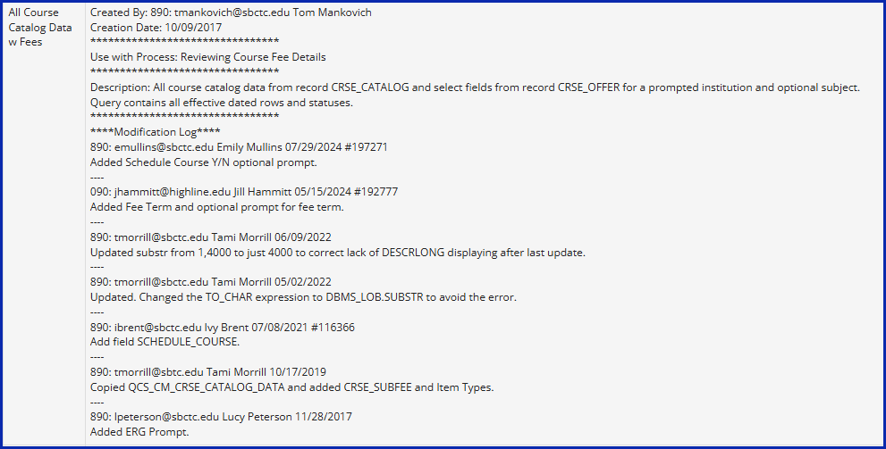

##### Template Example

***Special Instruction Section***<BR>  
Edit: SBCTC FA Only<BR>  
Run: Run in pop-update process<BR>  
********************************<BR>  
Created By: 890: cburrow@sbctc.edu Connie Burrow<BR>  
Creation Date & Ticket #: 06/25/2024 #195052<BR>  
********************************<BR>  
Use with Process: Award, Packaging and Disbursement FLF Process<BR>  
********************************<BR>  
Description: Selects students who have a financial aid item-type that is greater than zero and has no value entered in Var Num1 (Fall) field of Assign Packaging Variable page. <BR>  
**NOTE** If you're manually assigning the packaging variables on a student before the batch process is run, be sure to update all four fields: Var Num1 (Fall), Var Num2 (Winter), Var Num3 (Spring) and Var Num4 (Summer).  
Save As of CTC_FA_ASSIGN_PKG_VAR_F. <BR>  
********************************<BR>  
***Modification Log***<BR>  
890: cburrow@sbctc.edu Connie Burrow 01/08/2025 #207536<BR>  
Added criteria to look for a value greater than zero entered in Var Num1 or Var Num2 or Var Num3 or Var Num4 field of Assign Packaging Variable page. <BR>

##### Blank Template

***Special Instruction Section***<BR>

Edit: <BR>

Run: <BR>

********************************<BR>

Created by:<BR>

Creation Date & Ticket #:<BR>

********************************<BR>

Use with process:<BR>

********************************<BR>

Description:<BR>

********************************<BR>

****Modification Log****<BR>

---<BR>

#### Edited by SBCTC Only Queries

As stated above, some queries can only be modified by SBCTC. They will have “**Edited by SBCTC only**” as the first line of the Query Definition Template. This must remain as the first line if applicable. If the query is not SBCTC Only Edit and there are not any special instructions, do not include this section and instead, start the template with “Created by.”

### Prompts

* Queries not using at least one secure college specific prompt will not be migrated.
  + Any unusual cases where a college prompt will not be used must first be approved by the Query Governance Committee. These college specific queries are maintained by the institution.

Runtime Prompts are pop-up selection windows that appear when the query is run which ask the end user to enter or select something from a list – for example, a specific institution. It is important to keep in mind that college-identifying prompts must be developed for every query to increase the value of the query and for security. If a query is developed for a specific institution, that query will only ever be good for that institution; however, if a prompt is used where the end user selects their institution, the query now becomes usable for everyone, regardless of institution. Queries will be reviewed for prompts before migration. Queries without prompts will generally not be migrated. Queries should also include a time-based prompt such as a specific term or time-period.

In most cases, use the Prompt Table Edit Type as this Edit Type disallows typos from end users when they are entering values into the prompt. There will, of course, be instances when other Edit Types will need to be selected, however in most cases, it will be appropriate to use the Prompt Table Edit Type.

#### Query Prompt Table Security

Though query security is determined based on the roles assigned to each developer, it is required to add an additional layer of security though prompts. As stated above, all queries in all pillars should include an Institution, Company, Business Unit, or SetID prompt. All pillars have secure records that must be used with one of these college-identifying fields as a prompt. Any exceptions to this rule must first be approved by Data Services. Required Secure Prompt Tables as well as other recommended Prompt Tables are found in the document [Prompt Tables to Use](https://www.sbctc.edu/resources/documents/colleges-staff/data-services/peoplesoft-ctclink/prompt-tables-to-use.docx).

#### Commonly Used Prompt Tables

The [Prompt Tables to Use](https://www.sbctc.edu/resources/documents/colleges-staff/data-services/peoplesoft-ctclink/prompt-tables-to-use.docx) document also includes a list of fields commonly used as prompts and their corresponding recommended prompt table by pillar. It can be helpful to refer to this document when creating prompts.

### Public not Private Queries

Queries in PCD can be saved either private or public. ctcLink queries being migrated from PCD to PRD must always be saved as public so they can be seen and used by everyone. If all queries are public, it will prevent the duplication of effort that could happen if a query were private and not visible to others so was then reproduced.

### Query Organization – Folders and Favorites

Folders can be used to categorize and organize queries. Queries may only be stored in one folder at a time. Query folder organization is defined in the document [Query Folder List per Pillar.](https://www.sbctc.edu/resources/documents/colleges-staff/data-services/peoplesoft-ctclink/pillar-folder-lists.pdf) If a new folder assignment is desired, please submit a ticket to Data Services → ctcLink Reporting → Other. Some developers prefer to store draft queries in PCD in a personal folder, which is acceptable, just make sure to remove or change the folder name prior to making a migration request. Queries not in the proper folder will not be migrated. College specific folders are maintained by each institution.

#### Population Selection Queries and Folders

* Queries that use a BIND record that are not CEDQ data sources should be stored in the POPULATION SELECT folder.
* Queries that use a BIND record that are CEDQ data sources should be stored in the COMMUNICATIONS folder.

In addition to folders, users may also save queries in a favorites list for easy access and organization.

### Test the Query

Once the development of the query has been completed, the next step is to test that it returns correct results and adheres to the Query Development Standards outlined in this document. Testing the query prior to submitting a migration request will help ensure that the migration into the Production environment will happen quickly. It may be helpful to use the [Query Migration Request Form](https://www.sbctc.edu/colleges-staff/collegeaccess/resources/data-services/query-migration-request-form.pdf) as a guide to query testing. Please also include the prompt values used in testing in the Query Migration Request Form.

### Performance Standards

Users will also need to test that their query is efficient and does not take too long to run. Inefficient queries can use up valuable resources. The best way to ensure the query is efficient is to run it and verify that its run time is less than one minute, preferably just a few seconds. Also aim to have the smallest number of rows returned by the query as possible. A good sign that the query is returning too many rows is if the message “Query Result Set Too Large” is received indicating that scheduling the query is required to see the full results.

### College-Specific Queries

Queries should always be designed for global use, with criteria and prompts that work across all institutions. However, when this isn’t feasible, a college-specific query may be created and migrated to production with approval from the Query Governance Committee (QGC).

A college-specific query is written by a college for its own use. It may include hardcoded values and/or criteria based on business processes unique to that college.

All college-specific queries require approval by the QGC. This will result in a longer turn-around time for migrations.

These queries will be identified by their naming standard and folder.

#### Alternate Options to College-Specific Queries

#### It is generally recommended to avoid hardcoding. Alternative solutions include:

* dataLink (preferred tool for college-specific reporting needs).
* Scheduled Queries — retain prompt values using a user-defined Run Control ID.
* Optional and default prompts.
  + Training on prompts and scheduling is available for users and developers.

#### College-Specific Query Standards and Conventions

College-specific queries must follow established standards and conventions. While most align with global query standards, the naming convention and folder assignment will differ.

Important: College-specific queries must include a college-identifying prompt. If a prompt cannot be used, the reason must be documented in the [College-Specific Query Decision Making Tool Form](https://www.sbctc.edu/resources/documents/colleges-staff/data-services/peoplesoft-ctclink/college-specific-query-tool.xlsx) and security must be enforced via a secure record join.

Default prompt values can be used for these queries, but default values bypass prompt table security. If a default value is used in a secure prompt, a secure record join must be used to secure the query.

##### Query Name

Each college-specific query will have the following naming standards:

* Character 1 will represent the ctcLink pillar.
  + C = Campus Solutions (CS)
  + F = Financial Supply Chain Management (FSCM)
  + H = Human Capital Management (HCM)
* Characters 2, 3, and 4 will be the college numeric identifier such as 010, 172, 230.
  + District specific queries will be the district numeric identifier such as 060 or 170.
* Character 5 is an underscore.
* Characters 6 and 7 will identify the module.
* Character 8 is an underscore.
* The remaining 22 characters should be descriptive of the query.

Examples:

* + C030_SF_3RD_PRTY_STUDENT_DATA
  + F220_AP_VOUCHER_USE_TAX
  + H140_HR_ESD_SHARED_WORK

##### Folder Name

Each college will have one college-specific query folder. All college-specific queries must be assigned to the college folder.

The name of the folder will be WA followed by the college numeric identifier such as 010, 172, 230.

Examples:

* WA050
* WA120
* WA300

##### Additional Standards

* College-specific queries must adhere to all other global query standards and conventions.
* Colleges are responsible for maintaining their college-specific queries and folders.
* They will undergo Standards, Technical, and SME reviews in the same way as global queries.

#### Defining College-Specific Queries

A query is considered college-specific if it:

* Contains hardcoded criteria not suitable for global queries, and/or
* Is based on business processes unique to a specific college.

#### Steps to Request a College-Specific Query

* Fill out the [College-Specific Query Decision Making Tool Form](https://www.sbctc.edu/resources/documents/colleges-staff/data-services/peoplesoft-ctclink/college-specific-query-tool.xlsx).
* Obtain QGC Approval. No quorum will be necessary. The outcome will be decided by a majority vote.
  + Monthly QGC Meeting Approval
    - Submit a ticket to the Reporting Team with the filled-out [College-Specific Query Decision Making Tool Form](https://www.sbctc.edu/resources/documents/colleges-staff/data-services/peoplesoft-ctclink/college-specific-query-tool.xlsx) to add the vote to the QGC Meeting Agenda at least 1 day prior to the QGC meeting.
      * QGC meetings are typically held on the last Wednesday of the month.
    - Attend the monthly QGC meeting to present the request or send a proxy.
    - The Reporting Team will update the ticket with the result of the vote.
    - After approval, follow the query migration process.
      * Include the ticket number where approval was received in the Request Detail of the migration request ticket.
  + Email Approval

Urgent query requests that require approval prior to the next QGC meeting can be submitted to the QGC for an email vote.

* + - Submit a ticket to the Reporting Team with the filled-out [College-Specific Query Decision Making Tool Form.](https://www.sbctc.edu/resources/documents/colleges-staff/data-services/peoplesoft-ctclink/college-specific-query-tool.xlsx)
      * ***A business reason for the urgent request must be included in the request detail of the ticket.***
    - The Reporting Team will send out a notification to the Reporting Leads asking for their vote.
      * 1 working day for Reporting Lead responses.
    - The Reporting Team will update the ticket with the result of the vote.
    - After approval, follow the query migration process.
      * Include the ticket number where approval was received in the Request Detail of the migration request ticket.

## PHASE II: Submit a Migration Request

The last step in the development process, and the second phase of the overall QDLC, is to request the query be migrated into the PRD environment. Follow the steps below:

* Log in into the SBCTC Service Desk



* If not prompted into the Request screen, click in the “Request” icon.

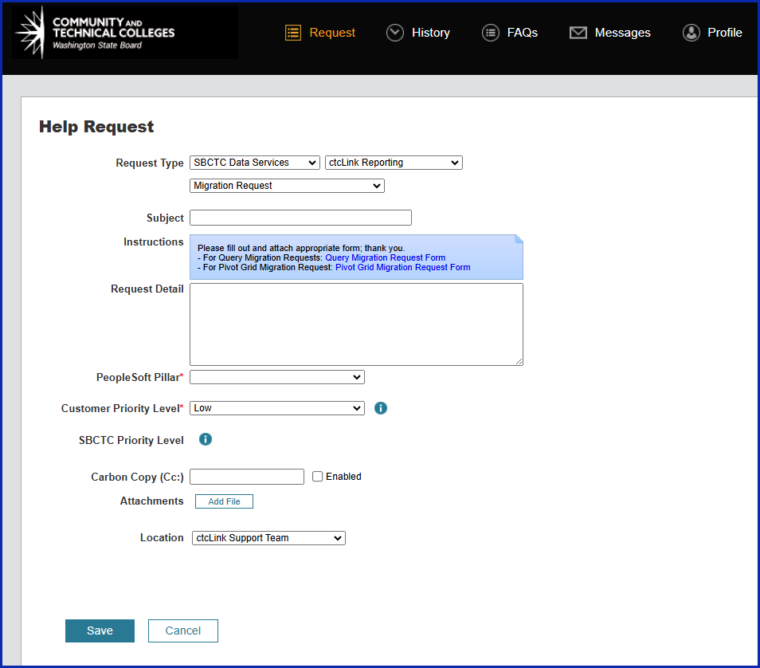

* On Request Type, select “SBCTC Data Services”, which will bring a second drop-down list.
* Select “ctcLink Reporting”, which will bring a third drop-down list.
* Select “Migration Request”.
* Fill in the “Subject” field.
* Describe the request with as much detail as possible.
* Choose the PeopleSoft Pillar from the drop-down list. This is a required field.
* From the “Instructions” field, click on the link “Query Migration Request Form” to open the form.
* Fill out the Query Migration Request form completely
* Click the three dots in the upper right corner to save the form on the users’ PC (the completed form needs to be attached in the Migration Request)

The Next step is to attach the Query Migration Request Form to the Migration Request:

* Click “Add File” button



* Click “Browse” to find the file
* Once found, click “Open”
* Click “Upload”, once done the file name should be seen below the “Add File” button
* Location stays as SBCTC.
* Finally, click “Save”

The Query Migration Request Form is used by Data Services and helps ensure that the Query Developer has reviewed their query for compliance and performance before submitting for migration. **This form can also be used as a guide during development work to ensure the standards described in this document are being followed.**

## PHASE III: Migration to Production

The Data Services Reporting Team will review the query for compliance and functionality, and an advanced review will be performed. If there are any concerns with the query or its compliance with any of the standards listed in this document, it will be sent back to the developer to resolve before migration. Once the query is approved by Data Services, it is sent to the hosting service for migration. Thequery will be added to View Query Search Listing in[metaLink](https://dataservicesmetalink.sbctc.edu/)once it is migrated.For access to metaLink, please email [dataservices@sbctc.edu](mailto:dataservices@sbctc.edu) with your name, email address, phone number, and college.

### Query Migration Schedule

Query Migrations occur twice a week on Tuesdays and Thursdays.

If you intend to have your **query migrated on Tuesday, the latest time to submit your migration request ticket is Monday at 12pm.** If your ticket is not submitted on or before 12pm, your query will be reviewed for migration during the next migration window. Also, if you intend to have your **query migrated on Thursday, please submit your migration request ticket by Wednesday at 12pm.** If your ticket is not submitted on or before 12pm, your query will be reviewed for migration during the next migration window. Query requests sent for migration by Monday at 12pm should be available in Production on Wednesday morning, while those sent in by 12pm on Wednesday should be available in Production by Friday morning.

Note: If there is a Monday holiday, the migration project will be submitted on the preceding Friday. Submissions are due by 12 pm on that Friday.

## PHASE IV: Modification of Existing Queries

### Modifying Queries Created by Others

* Do not save over the original query. Instead create a DEV_ version.
* Understand how a modification will impact the original purpose.
* Determine if a modification is acceptable, or if a new query needs to be developed. If modifying an existing query, make a copy first.
* Get Approval

#### All Queries Created by State Board Employees

* + - Request Approval from the Data Services Reporting Team.
      * It is strongly preferred that a ticket be submitted requesting approval of the modification before any changes are made to the query, but approval may be requested with the migration request ticket.
      * If requesting approval within the migration ticket, it is required to note in the Request Detail that modification approval is also requested.
        + This step is in addition to the information requested in the QMRF. This does not replace any information requested in the QMRF.
        + Example of combined approval and migration request.

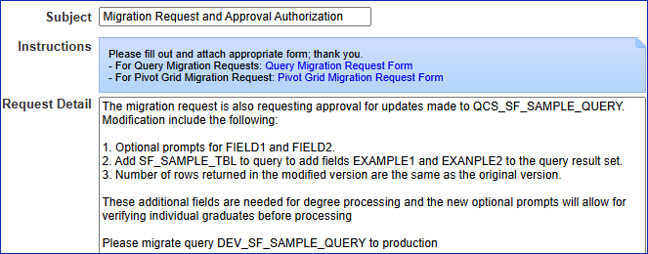

#### Queries Created by College Query Developers

* + - Original Query Developer is Available
      * Get approval to modify the query from original query developer.
      * Approval for the modification must be obtained prior to submitting the migration request. Attach the approval to the migration ticket.
    - Original Query Developer is Not Available
      * For queries originally developed within the same institution, modification approval may be obtained from the institution’s Reporting Lead.
      * For queries developed by a different institution, modification approval must be obtained from the Data Services Reporting Team.
        + If you are requesting approval from the Reporting Team, please follow the same steps listed above under the bullet point “Request Approval from the Data Services Reporting Team.”
* Repeat QDLC starting at the second step of Phase I.
* If desired, request that the original query be removed from PRD.

Please do not modify any existing queries without first analyzing the impact of the modification with the original creator or the ERP (Enterprise Resource Planning) Pillar lead. Approval is always required to make a modification to an existing query. Some queries are used for business processes, and changing the query may negatively impact it. If approved to make changes to an existing query, make a copy first.

If a query is found that is close to what is needed but that is not quite right, it is recommended to use that query as a base that can then be changed to fit current needs. These queries must be saved using **“Save As”** to save the query to a new name after which, the query can then be modified. **All FA queries, whether new or for a modification, must first be approved by the SBCTC Financial Aid Support Team.**

#### Modifying QCS_FA or CTC_FA Financial Aid Queries

* All Financial Aid queries, both new query requests and modification of existing queries, need to be approved by the SBCTC Financial Aid Support Team.
* Assign to the Financial Aid Pillar Lead via the Service Desk to request modification.

#### Modifying Delivered Queries

Queries that are delivered by Oracle are found in the DELIVERED folder. These queries do not follow the QXX or CTC naming convention. If a Query Developer makes a modification to one of these queries, any changes made will be overwritten and lost at the next system upgrade. Therefore, all changes to a delivered query must be saved as a new query using the “Save As” button. The new queries must follow the standard conventions listed in this document.

# Other Reporting Tools Development Conventions and Protocol

While creating queries will be the main area most Query Developers will work in, there are additional reporting tools that will become available for use as the Query Developer gains skill and knowledge. Following the correct conventions when using these tools is also especially important for consistency and continuity in searching.

## Population Selection Conventions and Protocol

Population Selection queries use BIND records to retrieve a select group of people, organizations, or records for processing within batch processes, reports, or mass updates. They are also referred to as Pop Select Queries. A Population Selection or Pop Select query is just a tool to gather IDs. They are not meant to be a standalone query that provides data outside of what is needed to run the batch process to which they are associated.

The results of a pop select query should only contain those fields that are needed to run the batch process. The bind record has all the necessary fields. If one or two additional data fields are needed to validate the population, they can be included in the query results, but they must be kept to a minimum and be necessary as opposed to convenient.

* An example would be to include the name when the EMPLID is included with the results. Name is convenient but not needed when you have the EMPLID.

Pop select queries should be written to be effective and efficient. One way to do that is to keep the fields in the query to only those necessary to run the process.

* If a query runs long in query viewer, it will run long as a pop select.
* Unnecessary data could lead to performance issues.
* The query must not contain duplicate IDs.
* Pop select queries may not use optional prompts.

If additional data is needed for population validation, then create a second query related to the pop select query. These queries can be cross refenced in the query properties which can be viewed by everyone in MetaLink. Use the same selection criteria but do not include the bind record. This data is available on other tables. Bind records should only be used in pop select queries. Queries using bind records are not captured as part of the annual query maintenance as they are associated to a business process so bind records should not be used in queries that are not pop selects or CEDQ data sources.

We will not review and make changes to existing pop select queries unless needed. This standard will be applied as updates and migration requests are submitted for these queries.

### Population Selection Description

* Enter a brief description of the query.

### Population Selection Definition

* POPULATION SELECT queries have the same standard Definition field found in Query Manager. However, in addition to the standard information included in the boilerplate, developers must also list the process with which the query is used.

### Population Selection Folder

* Queries that use a BIND record that are not CEDQ data sources should be stored in the POPULATION SELECT folder.
* Queries that use a BIND record that are CEDQ data sources should be stored in the COMMUNICATIONS folder.

## CEDQ Conventions and Protocol

Custom Extract Data Queries (CEDQs) are added to Communication Data Sources to pull data to populate live fields in 3C Communications. By default, Communication Data Sources provide bio demo information, such as names and addresses, of communication recipients. CEDQs are used to pull other data that are not already included in the Communication Data Source.

Any information in ctcLink that can be queried can also be pulled by a CEDQ.

CEDQs are run by ctcLink when a 3C Communication is generated. The results from the query can then be added to live fields in 3C Communications. CEDQs can create highly personalized and detailed communications and are an essential tool for colleges that use the 3C Communications functionality.

### CEDQ Naming Convention

Use the naming convention for standard queries.

* Example: QCS_CC_CEDQ_ACAD_STANDING

Q/Pillar Module CEDQ Description

### CEDQ Description

Enter a brief description of the query.

### CEDQ Definition

CEDQ queries have the same standard Definition field found in Query Manager.

### CEDQ Folder

## Queries that use a BIND record that are not CEDQ data sources should be stored in the POPULATION SELECT folder.

## Queries that use a BIND record that are CEDQ data sources should be stored in the COMMUNICATIONS folder.

## BI Publisher Conventions and Protocol

BI Publisher is a PeopleSoft delivered reporting tool that allows users to choose the output type of a report and for specific formatting and presentation of data. These reports use queries, Connected Queries, or Composite Queries as data sources. BI Publisher reports follow the same naming convention as standard queries with the caveat that they will begin with B, which stands for BI Publisher.

### BI Publisher Naming Convention

The naming convention for BI Publisher reports only begins with B instead of BI to save space as the name can only be 12 characters long.

* Example: BFS_EX_GLBAL

B/Pillar Module Description

### BI Publisher Description

Enter a brief description of the report.

### BI Publisher Definition

BI Publisher reports do not have the standard Definition field found in Query Manager. Enter as much information as possible into the query that will form the data source for the BI Publisher report.

### BI Publisher folder

BI Publisher reports are not stored in folders. The standard queries that make up the BI Publisher report are. Any standard query used in a BI Publisher report must be stored in the BI PUBLISHER folder.

## BI Publisher Data Sources

Data sources for BI Publisher reports are:

* PS Queries
* Connected Queries
* Composite Queries

## BI Publisher Data Source Conventions

### PS Queries for BI Publisher

Queries used as data sources for BI Publisher should have a BI designation at the beginning of the query name. The naming convention is: BIXX_XX_XXXXXXXXX.

* Example: BIFS_AR_ITEM_DST_GL

BI/Pillar Module Description

Queries used in BI Publisher must be stored in the BI PUBLISHER folder.

### Connected Queries for BI Publisher

Connected Query allows for the creation of a single XML file based on a set of queries with parent-child relationships. Please see the Connected Query section of this document for information on Connected Query and protocol.

### Composite Queries for BI Publisher

Composite Query enables you to combine data from existing base queries and then apply filters, aggregates, and so on before presenting the report results, which show the combined data set. Please see the Composite Query section of this document for information on Composite Query and protocol.

## Pivot Grid Conventions and Protocol

Pivot Grid will allow Query Developers to efficiently create visually effective graphical representations of data.

### Pivot Grid Naming Convention

The Pivot Grid naming convention is: PGXX_XXXXXXXXXX.

* Example: PGCS_FTE_SUMMARY

PG/Pillar Description

### Pivot Grid Description

The Pivot Grid description field is the only area where developers can enter notes about the grid. There is no definition field for a Pivot Grid; however, there is a large character limit on the description field. Include as many of the following as possible when entering the description:

* Detailed description of purpose of Pivot Grid
* Any specific aggregation applied
* Include key search terms
* Describe any changes or updates made to an existing grid including ***approval***for the modification
* College code and email address of developer, for example, 890: [pmcdaniel@sbctc.edu](mailto:pmcdaniel@sbctc.edu)
* Date Pivot Grid was created or updated
* Business process number, if applicable
* If adding to the Description, place the latest information at the top of the list with a dashed line between the new and existing entries. This will allow the definition to be read clearly in descending order

### Pivot Grid Definition

There is no definition field for Pivot Grids. Use the description field provided to write a thorough description of the Pivot Grid as explained above in Pivot Grid Description.

### Pivot Grid Folder

Pivot Grids are not stored in folders. The standard queries that make up the Pivot Grid are. Any standard query used in a Pivot Grid report will be stored in the PIVOT GRID folder.

## Pivot Grid Data Sources

Available Pivot Grid data sources are:

* Standard Queries
* Composite Queries
* PeopleSoft Components

## Pivot Grid Data Source Conventions

### PS Queries for Pivot Grid

Queries used as data sources for Pivot Grids should have a PG designation at the beginning of the query name. The naming convention is: PGXX_XX_XXXXX

* Example: PGFS_AR_ITEM_DST_GL

PG/Pillar Module Description

Queries used in Pivot Grids must be stored in the PIVOT GRID folder.

### Composite Queries for Pivot Grid

Composite Query enables you to combine data from existing base queries and then apply filters, aggregates, and so on before presenting the report results, which show the combined data set. Please see the Composite Query section of this document for information on Composite Query and protocol. Composite Queries can be used as a data source for Pivot Grids.

### Components for Pivot Grid

Using a component as a data source for a Pivot Grid allows the developer to select a component and create a Pivot Grid based on the component properties.

## nVision Conventions and Protocol

PS/nVision is a sophisticated tool for creating business reports in Microsoft Excel. Working within Microsoft Excel, users can create a report layout that defines both the data to retrieve and the format of the report. Using PS/nVision, users can create report layouts that summarize information from the PeopleSoft database and use the drill down feature to expose the supporting details. Users can share report layouts across multiple business units and time periods, creating reports that “roll” from unit to unit or period to period without changing the data-retrieval criteria.

PS/nVision works within spreadsheets. Access PS/nVision features from a special PS/nVision menu within Microsoft Excel to create templates (layouts) for data retrieval. Once a report layout is created (XNV file), users can use it to automatically format data. PS/nVision selects data from the PeopleSoft database using ledgers, trees, and queries.

### nVision Naming Convention

Because of the extremely limited character allocation for nVision report names, the naming convention for nVision reports is only a brief description. nVision report names are limited to 7 characters. There are no delivered nVision reports from which we would need to differentiate our custom reports so a designation of NXX is not necessary.

* Example: IPEDS

Description

Note: Only State Board staff will have access to create nVision reports.

### NVision Description

Enter a brief description of the report in the Title field of Define Report Request

### NVision Definition

nVision reports do not have a definition field. Enter as much information as possible in the query definition if using a query as a data source.

### NVision Folder

NVision reports are not stored in folders. Any standard query used in a nVision report will be stored in the NVISION folder.

## nVision Data Sources

nVision data sources are:

* Standard Queries
* Ledgers
* Trees

## nVision Data Source Conventions

### PS Queries for nVision

Queries used as data sources for nVision should have the NV designation at the beginning of the query or Connected Query name. The naming convention is: NVXX_XX_XXXXX.

* Example: NVFS_AR_ITEM_DST_GL

NV/Pillar Module Description

Queries used in nVision reports must be stored in the NVISION folder.

### Ledgers and Trees for nVision

Ledgers and Trees are already named and do not require further conventions when used as data sources for nVision reports.

## Connected Queries

Connected Queries are used as data sources for reports that use XML as they only produce XML. ctcLink currently only uses Connected Queries as data sources for BI Publisher reports. PeopleSoft Connected Query allows for the creation of a single XML file based on a set of queries with parent-child relationships. It is important to designate which queries make up the Connected Query and what their role is within the Connected Query.

Connected Queries can be “broken down” into three parts:

* Connected Query – hierarchal object created from multiple existing queries, which produces the XML output.
* Parent Query – A parent query is a query that has one or many child queries. The parent query is the top-level query in a Connected Query. The top-level query should normally be where prompts are developed.
* Child Query – A child query is a query that has a single parent query. A child query can have one or more sibling queries. Fields in a child query are mapped to related fields in the immediate parent query.

Connected queries are found in the Connected Query Manager or Connected Query Viewer but only produce XML. A Connected Query is created by connecting parent and child queries together by mapping related fields. An example of when to use a Connected Query would be for a report that includes detailed as well as totaled information. The Connected Query creates the final XML output that is then used as a data source for BI Publisher or other tools that can use XML.

### Connected Query Conventions Overview

The Connected Query is designated by the prefix CQXX where XX is the pillar name. The parent query is a standard PS Query and is designated by the prefix CQXX and a suffix of _P to designate it as a parent query. Each child query is also a standard PS query and is also designated by the prefix CQXX but will have a suffix of _X where X is the child number to designate it as a child query. The number does not denote any particular order but is instead just a way of differentiating each child query since all queries used in a Connected Query, as well as the final Connected Query report, share the same base name. Use the description field for each parent and child query to provide a brief description of the purpose of the query.

* Example:
  + Connected Query: CQHC_PY_PAYROLL_REGISTER
  + Parent Query: CQHC_PY_PAYROLL_REGISTER_P
  + Child Queries: CQHC_PY_PAYROLL_REGISTER_1

CQHC_PY_PAYROLL_REGISTER_2

CQHC_PY_PAYROLL_REGISTER_3

* All queries share the same base name.
* Parent and child queries should be stored in the folder of the object being created. For example, queries being created for a BI Publisher report would be stored in the BI PUBLISHER folder.
  + Example: Connected Query – CQCS_SF_ITEM_DUE_AS_OF

### Connected Query Conventions and Protocol

#### Connected Query Naming Convention

Connected Queries will begin with CQ. There is a 30-character limit on the Connected Query’s name.

CQXX_XX_XXX……XXXX – where CQ stands for Connected Query

* Example: CQHC_PY_PAYROLL_REGISTER

CQ/Pillar Module Description

#### Connected Query Description

Enter the description of the report.

* Example: “Payroll Register Report”

#### Connected Query Definition

Connected Queries do not have the standard Definition field found in Query Manager. However, there is a Comments box underneath the Description where additional information related to the Connected Query should be stored. Related queries are listed in the body of the Connected Query manager page and do not have to be further defined in the comments section.

#### Connected Query Folder

Connected Query reports are not stored in folders. Parent and child queries should be stored in the folder of the object being created. For example, queries being created for a BI Publisher report would be stored in the BI PUBLISHER folder.

## Connected Query Parent and Child Queries Conventions

Parent queries are standard queries found within Query Manager, so it is important to designate them appropriately, so they do not get used or modified incorrectly. They will start with CQ to designate them as part of a Connected Query.

### Parent Query Naming Convention

CQXX_XX_XXX……XXXX_P – where P stands for Connected Query Parent

* Example: CQHC_PY_PAYROLL_REGISTER_P

CQ/Pillar Module Description Connected Query Parent Suffix

Parent queries should be stored in the folder of the object being created. For example, queries being created for a BI Publisher report should be stored in the BI PUBLISHER folder.

### Parent Query Description

Enter a brief description of the query.

* Example: “Payroll Register Report by College”

### Parent Query Definition

Enter additional details regarding the Parent Query. Related queries are listed in the body of the Connected Query manager page and do not have to be further defined in the query definition.

* Example: 890: lpeterson@sbctc.edu Lucy Peterson 10/04/2017

Used in Connected Query: CQHC_PY_PAYROLL_REGISTER

### Child Query Naming Convention

Child queries are standard queries found within Query Manager, so it is important to designate them appropriately, so they do not get used or modified incorrectly. They will start with CQ as they will be used in a Connected Query.

CQXX_XX_XXX……XXXX_1 - where 1 stands for Connected Query Child 1

CQXX_XX_XXX……XXXX_2 - where 2 stands for Connected Query Child 2

CQXX_XX_XXX……XXXX_3 - where 3 stands for Connected Query Child 3

* Example: CQHC_PY_PAYROLL_REGISTER_1

CQHC_PY_PAYROLL_REGISTER_2

CQHC_PY_PAYROLL_REGISTER_3

CC/Pillar Module Description Connected Query Child Number Suffix

Child queries should be stored in the folder of the object being created. For example, queries being created for a BI Publisher report should be stored in the BI PUBLISHER folder.

### Child Query Description

Enter a brief description of the query.

* Example: “Payroll Register Report Totals”

### Child Query Definition

Enter additional details regarding the Child Query. Related queries are listed in the body of the Connected Query manager page and do not have to be further defined in the query definition.

* Example: 890: lpeterson@sbctc.edu Lucy Peterson 10/04/2017

Used in Connected Query: CQHC_PY_PAYROLL_REGISTER

## Composite Queries

Composite Query enables users to combine data from existing base queries and then apply filters, aggregates, and so on before presenting the report results, which show the combined data set. Composite Query retrieves multiple levels of related information on existing base queries and presents the combined data as a single and flattened query result. The Composite Query is comprised of multiple base queries. It is important to designate which queries make up part of a Composite Query and what their role is within the Composite Query. Composite Queries can be “broken down” into two parts:

* Composite Query - hierarchical object created from multiple existing queries.
* Base Query - A query that is joined by field to other queries then tied together as a Composite Query that can be used as a data source for Pivot Grid.

Composite Queries are found in the Composite Query Manager. A Composite Query is created by connecting multiple standard PS queries together. Composite Queries can be used as data sources for BI Publisher, Pivot Grid, or they can be run in Composite Query Manager to preview the results.

### Composite Query Conventions Overview

The Composite Query is designated by the prefix COXX where XX is the pillar name. The base queries are designated by the suffix _X where X is the base query number. The descriptive portion of the names for the final Composite Query and the base queries should be the same for continuity, only if the base queries are being developed specifically for use in a Composite Query. Remember, Composite Queries use standard PS Queries, so it is possible to just use existing queries in a Composite Query. In that instance, the name of the existing PS query does not need to be changed. Just update the query definition field to include that the query is being used as part of a Composite Query and list the Composite Query name and any sibling base queries. The query will continue to run as a stand-alone query and as part of the Composite Query.

* Example 1 – Base queries are being developed specifically for use in a Composite Query:
  + Composite Query COHC_PY_COMPOSITE_EXAMPLE
  + Base Queries: COHC_PY_COMPOSITE_EXAMPLE_1

COHC_PY_COMPOSITE_EXAMPLE_2

COHC_PY_COMPOSITE_EXAMPLE_3

Note that all queries share the same base name.

* Example 2 – Base queries are pre-existing standard PS queries
  + Composite Query COHC_PY_COMPOSITE_EXAMPLE_2
  + Base Queries: QCS_SR_ENROLL

QCS_SF_DUE_AMT

Note that the base queries names do not change, even though they are being used in a Composite Query

### Composite Query Conventions and Protocol

#### Composite Query Naming Convention

COXX_XX_XXXXXX – where CO stands for Composite Query. There is a 30-character limit on the Composite Query’s name.

* Example: COCS_PY_COMPOSITE_EXAMPLE

CO/Pillar Module Description

#### Composite Query Description

Enter a brief description of the Composite Query.

* Example: “Payroll Register Report

#### Composite Query Definition

Composite Queries do not have the standard Definition field found in Query Manager. However, there is a Comments box available in the Properties section of the Composite Query where additional information related to the Composite Query should be stored. Related queries are listed in the body of the Composite Query Manager page and do not have to be further defined in the Comments section.

#### Composite Query Folder

Composite Query reports are not stored in folders. Queries developed specifically for use in Composite Query should be stored in the reporting object's folder. For example, queries being created for a Pivot Grid report would be stored in the PIVOT GRID folder, whereas queries being developed for BI Publisher would be stored in the BI PUBLISHER folder.

Standard queries not specifically developed for use in Composite Query should remain in their current folder. The Definition field in the query should be updated to indicate the query is also used as part of a Composite Query.

## Composite Query Base Queries

Base queries are standard queries found within Query Manager. They can be developed for use in a Composite Query, or existing standard PS Queries can be used.

### Composite Base Query Naming Convention

If a query is being developed specifically for use in a Composite Query use the following convention:

COXX_XX_XXX……XXXX_1 - where 1 stands for Composite Base Query 1

COXX _XX_XXX……XXXX_2 - where 2 stands for Composite Base Query 2

COXX _XX_XXX……XXXX_3 - where 3 stands for Composite Base Query 3

* Example: COHC_PY_COMPOSITE_EXAMPLE_1

COHC_PY_COMPOSITE_EXAMPLE_2

COHC_PY_COMPOSITE_EXAMPLE_3

CO/Pillar Module Description Composite Base Query Number Suffix

Queries developed specifically for use in Composite Query should be stored in the reporting object's folder. For example, queries being created for a Pivot Grid report would be stored in the PIVOT GRID folder, whereas queries being developed for BI Publisher would be stored in the BI PUBLISHER folder.

If a standard PS query is being used in a Composite Query, do not change the name of the base query. Simply update the query definition field to include that the query is being used as part of a Composite Query and list the Composite Query name.

* Example: QCS_SR_ENROLL

QCS_SF_DUE_AMT

Pillar Module Description

Standard queries not specifically developed for use in Composite Query should remain in their current folder. The Definition field should be updated to indicate the query is also used as part of a Composite Query.

### Composite Base Query Description

Enter a brief description of the query.

* Example: “Payroll Register Report”

### Composite Base Query Definition

Enter additional details regarding the base query including the name of the Composite Query. Related queries are listed in the body of the Composite Query Manager page and do not have to be further defined in the query definition.

* Example: 890: [lpeterson@sbctc.edu](mailto:890:lpeterson@sbctc.edu) Lucy Peterson 10/04/2017

Used in Composite Query: COCS_PY_COMPOSITE_EXAMPLE

## Who Owns What Queries and Reports?

### Queries

* **QXX** = When the first three characters of the query are QXX (where XX is the pillar acronym) the query is owned and maintained by Data Services.
* **CTC** = Now owned by Data Services. Historically, some “CTC_” queries were owned and warrantied by **Ciber**, but others were developed by functional project staff.
* **Not QXX or CTC (DELIVERED)–** if the query does not begin with any of these prefixes, then it is a delivered query and is owned by Oracle.

### Financial Aid Queries

* **CTC_FA** =When the first five characters of a query are CTC_FA the query is owned by the SBCTC Financial Aid Support Team.
* All Financial Aid queries, both new query requests and modifications of existing queries, need to be approved by the SBCTC Financial Aid Support Team.

### Reports

* **BXX, PGXX** = Reports that begin with BXX or PGXX (where XX is the pillar acronym) the query is owned and maintained by Data Services. nVision reports do not have a designated character prefix due to the limited number of characters for the name. There are no delivered nVision reports from which we would need to differentiate our custom reports.
* **CTC_CUSTOM** = Developed reports in CTC_CUSTOM menu were originally created by Ciber. They are now owned and maintained by Data Services.
* **Not BXX, PGXX, CTC_CUSTOM** **(DELIVERED)** = if the report does not begin with any of these prefixes, then it is a delivered report and is owned by Oracle. The exception to this would be for nVision reports as explained above.

## Query Maintenance

The SBCTC Data Services Reporting Team will annually work on query clean-up in August. Queries that have not been run in one year will be moved to the ARCHIVE folder. Queries that have resided in the ARCHIVE folder for one year and were still not run (totaling two years without being used) will be deleted.

# Links Provided in this Document

|  |  |
| --- | --- |
| Commonly Used Tables Campus Solutions | <https://www.sbctc.edu/resources/documents/colleges-staff/data-services/peoplesoft-ctclink/cs-common-tables-for-reporting.xlsx> |
| Commonly Used Tables Finance | <https://www.sbctc.edu/resources/documents/colleges-staff/data-services/peoplesoft-ctclink/fin-common-tables-for-reporting.xlsx> |
| Commonly Used Tables Human Capital Management | <https://www.sbctc.edu/resources/documents/colleges-staff/data-services/peoplesoft-ctclink/hcm-common-tables-for-reporting.xlsx> |
| Data Dump Query Protocol | <https://www.sbctc.edu/resources/documents/colleges-staff/data-services/peoplesoft-ctclink/data-dump-queries.pdf> |
| metaLink Webpage | <https://dataservicesmetalink.sbctc.edu/> |
| Non-Disclosure Agreement | <https://www.sbctc.edu/resources/documents/colleges-staff/data-services/goldengate/ctclink-nondisclosure-form.pdf> |
| Prompt Tables to Use | <https://www.sbctc.edu/resources/documents/colleges-staff/data-services/peoplesoft-ctclink/prompt-tables-to-use.docx> |
| PSChrome Extension | [https://google.com/chrome/webstore](https://google.com/chrome/webstore%C2%A0) |
| Query Folder List per Pillar | <https://www.sbctc.edu/resources/documents/colleges-staff/data-services/peoplesoft-ctclink/pillar-folder-lists.pdf> |
| Query Module List by Pillar | [https://www.sbctc.edu/resources/documents/colleges-staff/data-services/peoplesoft-ctclink/pillar-module-lists.pdf](https://www.sbctc.edu/resources/documents/colleges-staff/data-services/peoplesoft-ctclink/pillar-module-lists.pdf%C2%A0) |
| Structure for Query Manager Access | <https://www.sbctc.edu/resources/documents/colleges-staff/data-services/peoplesoft-ctclink/structure-for-query-manager-access.pdf> |
|  |  |





Content is licensed under a Creative Commons Attribution 4.0 International License, unless noted otherwise.

Washington State Board for Community and Technical Colleges