SBCTC Memorandum
July 20, 2021

TO: BAR
FROM: John Ginther, Director
Accounting and Business Services
State Board for Community & Technical Colleges
SUBJECT: Unearned Revenue/Accounts Receivable/Allowance for Doubtfull Accounts
In ctcLink, revenue and accounts receivable entries are generated as soon as a student registers, which means at year end, revenue and receivables are overstated because it is future period activity. Summer and Fall tuition needs to be moved from revenue to unearned revenue (Step 1). Then receivables applicable to Summer and Fall need adjusted against unearned revenue (Step 2). These adjustments will result in reporting revenue for the current fiscal year only, reporting the amount of receivables that are legally enforceable as of June 30th, and reporting unearned revenue as the amount of cash received applicable to future fiscal periods.
Step 1: Unearned Revenue
- Run the query after July 1st of the current year: ‘QCS_SF_ACCTG_LN_TERM_REV_SRC’ (SF Rev Source for Unearned Amt) in Campus Solutions. Beginning the evening of July 1st, Campus Solutions SF journal generates to the new fiscal year so all unearned revenue will have been recorded in the prior fiscal year.
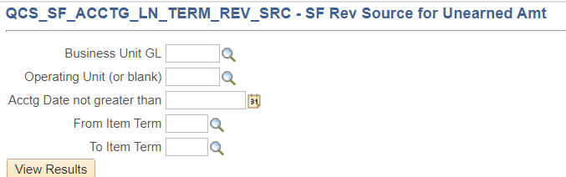
‘Business Unit GL’= Enter WAxxx (example WA000 for State Board)
‘Operating Unit (or blank)’ = Optional. A multi-college district can run this query by college (example: Spokane Falls Community College = ‘7172’. Single college district can leave this blank.
‘Acctg Date not greater than’ = Enter the last day of the fiscal year. Example: 06/30/2021 for FY21.
‘From Item Term’ = First term in the new fiscal year. Example: Summer Quarter =2215
‘To Item Term’ = Last term in the new fiscal year for which the may have enrolled students. Example: Fall Quarter =2217.
There is no harm in extending the ‘To Item Term’ to Winter quarter if you believe someone may have registered for Winter.
- Query Results. These are the fields returned by the query.
Run Date
GL Unit
Journal
Date
Item Term
Operating Unit
Acct
Fund
DeptID
Class
Proj/Grt
ActivityID
Sum Amount
Reference
Item Type
Line Descr
Line Date
Unit
Acctg Date
Period
Year
Status
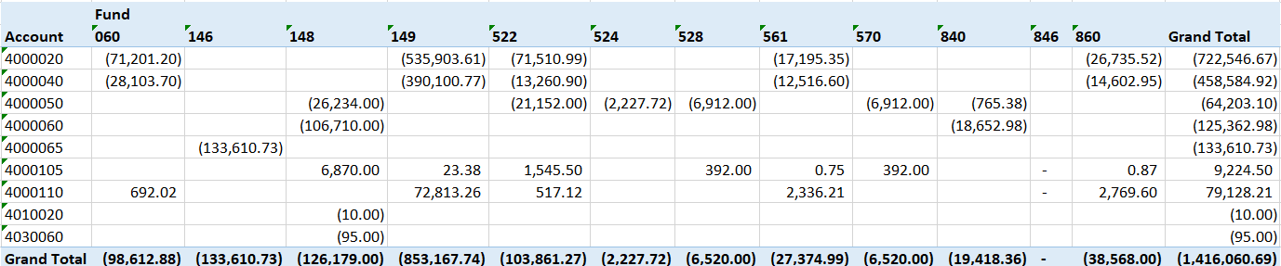
- Summarize the Results. We recommend creating a pivot table with the desired values needed. You may elect to record Unearned Revenue at the full chartstring level or at a single chartstring level. Since colleges’ financial statements are presented as a single column, either method is acceptable. Here is an example of the pivot table results for one college at the revenue and term level:
- Create a Journal. In Period 13 create an adjusting journal entry with a ADB date of 6/30/20YY with an automatic reversal date. Select the highlight ‘Reversal’ link. By using an automatic reversing journal you will not need to remember to reverse the journal in the new fiscal year.
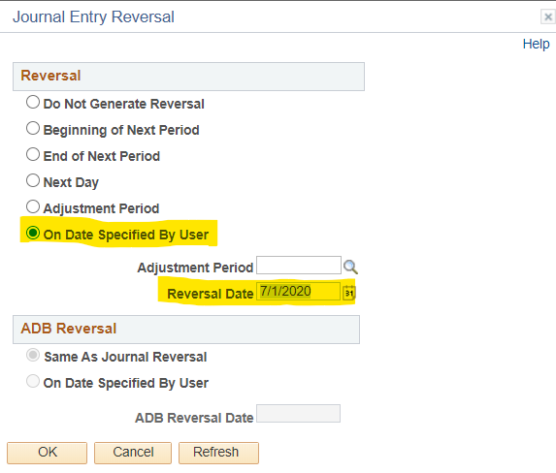
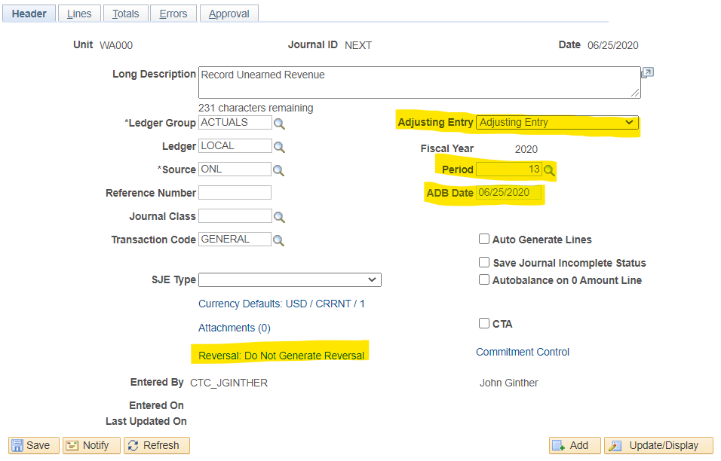
Complete the Journal Entry Reversal by selecting On Date Specified by User with a Reversal Date of 7/1/20YY.
- Record the journal lines. You should record the Unearned Revenue at the Fund/Class/Department/Project ID (for Bldg Fee)/State Purpose/Account level.
Debit Revenue: Fund/Class/Department/Project ID (for Bldg Fee)/State Purpose/40xxxxx
Credit Unearned Revenue: Fund/Class/Department/Project ID (for Bldg Fee)/State Purpose/2040010

- Review the Reversing Journal in the new fiscal year.

Step 2: Accounts Receivable Adjustment
- Schedule the query QCS_SF_ACCTNG_LN_ACCT_TERM2 in Campus Solutions to determine the amount of outstanding receivables as of 6/30/20xx year end. In Navigator, select Reporting Tools > Query > Schedule Query. Select the “Add a new Value” tab and enter a Run Control ID (this is unique to you, so describe it in a way that will make sense) and click “Add”. In the Query Name Field, enter the query QCS_SF_ACCTNG_LN_ACCT_TERM2 (or use the search function to find it).
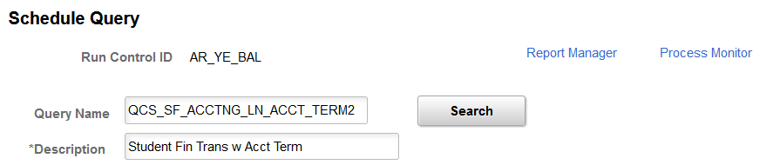
- A parameters box will pop up as follows:
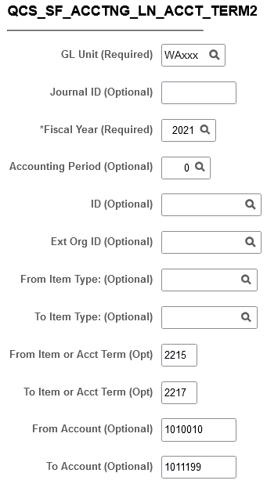
‘GL Unit’= Enter WAxxx (example WA000 for State Board)
‘Fiscal Year’ (required). = 2021 for data as of 6/30/2021
‘From Item Term or Acct Term’ = First term in the new fiscal year. Example: Summer Quarter =2215
‘To Item Term or Acct Term’ = Last term in the new fiscal year for which the may have enrolled students. Example: Fall Quarter =2217.
There is no harm in extending the ‘To Item Term’ to Winter quarter if you believe someone may have registered for Winter.
Once you have entered the parameters, click “OK”.
- Click “Save” at the bottom of the screen and then click “Run” at the top of the screen to go to the process scheduler screen.

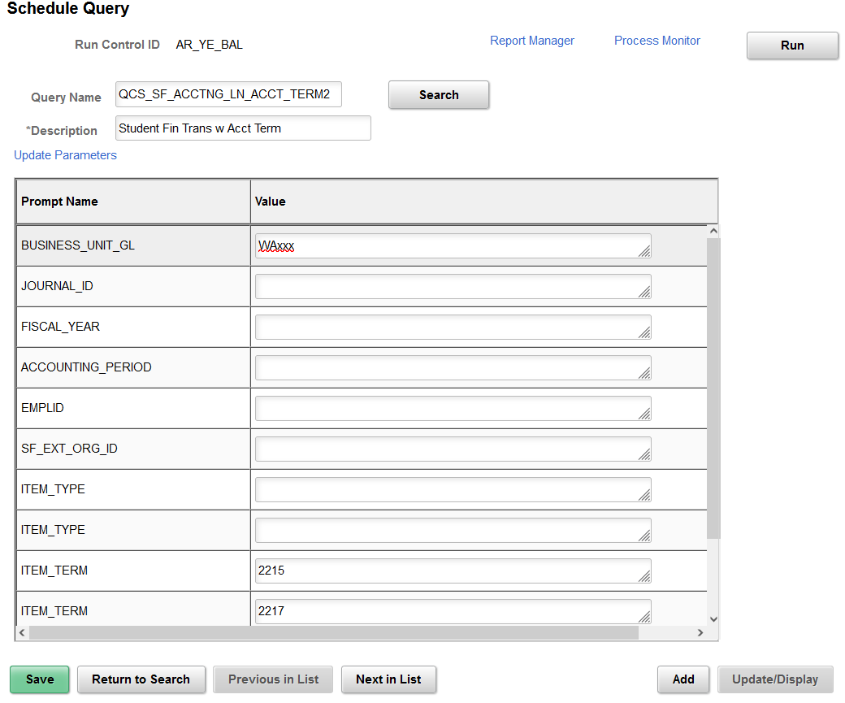
- On the “Process Scheduler Request Screen”, select “Type”=Web and “Format” = TXT, then click OK.
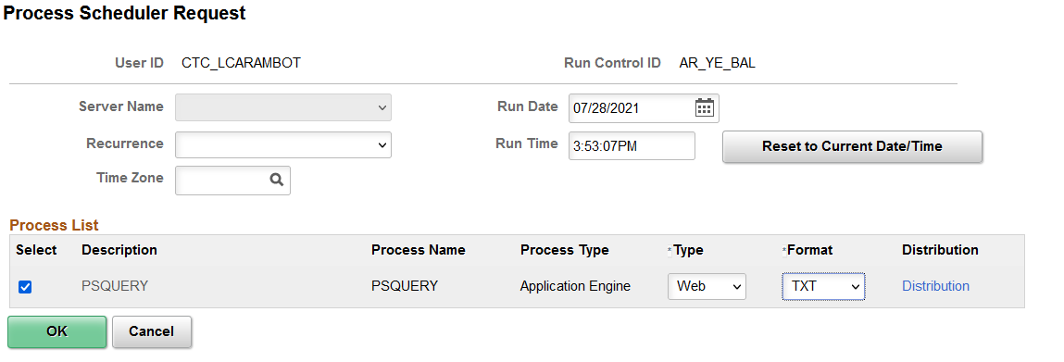
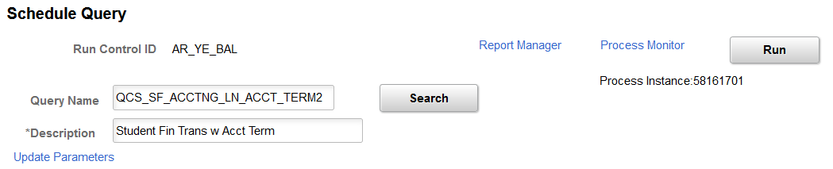
- This will take you back to the Schedule query screen where you will see “Process Instance” number that indicates the query is running. Make note of the number, then click on Report Manager.

- Report Manager. Once the query is complete, a completion date and time will populate on the list. Click on the “Report” Name.
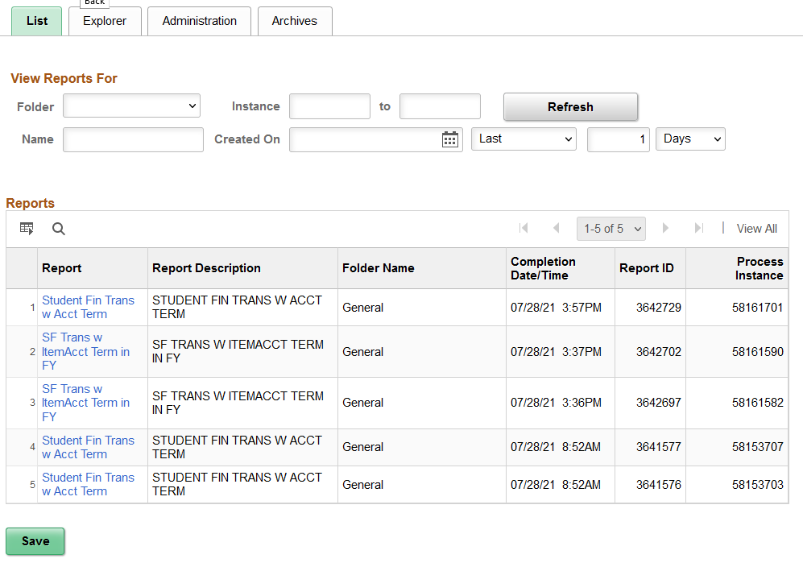
- Report. Click on the .csv file to open the report in excel.
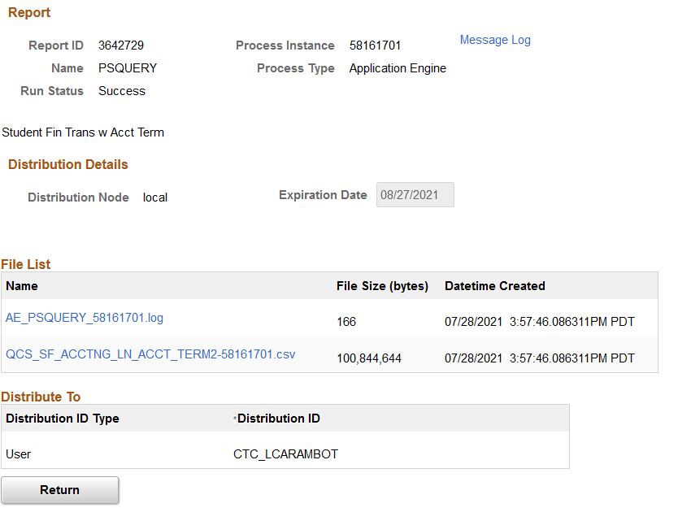
- Query Results. These are the fields returned by the query.
Run Date
Line
In Process
GL Unit
Journal
Date
Line #
Acct
Fund
Program
DeptID
Proj/Grt
Class
Chartfield2
Operating Unit
Amount
Status
Line Descr
Status
Line Date
Unit
Template
Acctg Date
Status
Instance
Currency
Period
Year
Amount
Ledger
ID
Item Nbr
Acct Term
Item Term
Item Type
- Summarize the Results. We recommend creating a pivot table with the desired values needed. You may elect to adjust at the full chartstring level or at a single chartstring level. If you include a term in your pivot data, make sure you are using Acct. Term. Since colleges’ financial statements are presented as a single column, either method is acceptable. Here is an example of the pivot table results for one college at the receivable balance and term level:
- Create a Journal. In Period 13 create an adjusting journal entry with a ADB date of 6/30/20YY with an automatic reversal date. Select the highlight ‘Reversal’ link. By using an automatic reversing journal you will not need to remember to reverse the journal in the new fiscal year.

- Record the journal lines. You should record the Unearned Revenue at the Fund/Class/Department/Project ID (for Bldg Fee)/State Purpose/Account level.

Debit Unearned Revenue: Fund/Class/Department/Project ID (for Bldg Fee)/State Purpose/2040010
Credit Accounts Receivable: Fund/Class/Department/Project ID (for Bldg Fee)/State Purpose/1011010 (SF Tuition Receivable) or 1011020 (SF Fees Receivable)

- Review the Reversing Journal in the new fiscal year.

Step 3: Allowance for Doubtful Accounts Adjustment
When calculating year-end allowance for doubtful accounts, make sure that you are excluding the summer and fall term amounts adjusted in step 2.
As stated in SAAM 90.20.70.b (21) the financial records must reflect the amount of receivable that is actually expected to be collected. The amount that is estimated to be uncollectible must be noted and subtracted from the total accounts receivable balance. This is done through specific accounts, which indicate a reduction of the receivable. At year-end, if it is determined that not all receivables will be collected, the allowance account must reflect the amount estimated to be uncollectible.
In governmental or expendable trust funds (Fund types 1 and 3) the allowance account (1010110) is offset with a revenue account (4000010) for tuition.
In proprietary fund types (Fund type 4) the allowance account (1010110) is offset with a bad debt expense account (5081270).
Colleges must maintain documentation demonstrating the logic used in determining the current allowance for doubtful accounts and the actual worksheets to determine the value. You should have these available for the auditors for both financial statement and compliance accounts.

