Bachelor’s Degree Program Approval Process and PLanning Timeline

New Baccalaureate Degree Program Approval Process
In September 2014, the State Board for Community and Technical Colleges approved a three-step process for community and technical colleges to propose a new baccalaureate degree program that involves three steps:
- Submission of a Notification of Intent (letter) during the Idea Stage to notify higher education partners.
- Submission of a Statement of Need (supply and demand analysis) during the Proposal Phase, which is sent to community colleges and the public baccalaureate institutions for 30-day review and is presented to the State Board for review during a study session.
- Submission of a Program Proposal (program design) during the Proposal Phase, which undergoes peer review if it is the college’s first bachelor’s degree program or if it is the first bachelor’s degree program of particular subject area. The proposal is then presented to the State Board at a regular meeting for a vote on its approval.
Details on each of the steps and document templates and examples are on SBCTC’s bachelor’s degree program approval web page at https://www.sbctc.edu/colleges-staff/programs-services/bachelors-degrees/bachelors-program-approval-application.

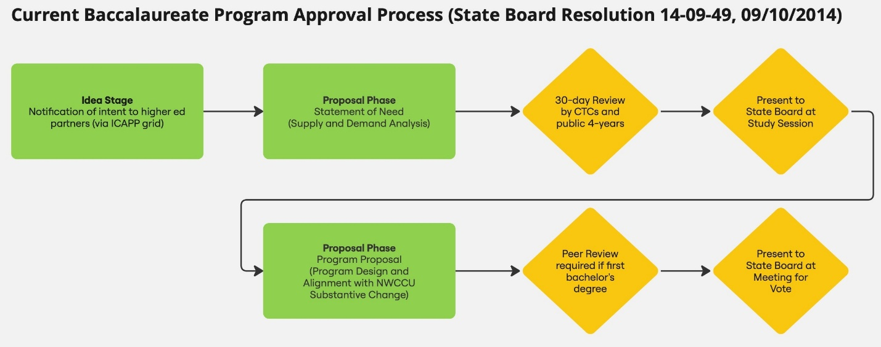

2025–2026 Planning Timeline

Notifications of Intent
During the Idea Stage, a Notification of Intent can be sent at any time by email to degreeprocess@sbctc.edu.

Statements of Need
Statements of Need are sent out for 30-day review and are presented at State Board study sessions three times per year. The table below has dates and deadlines for planning for when a college is ready to submit a Statement of Need. Statements of Need should be submitted by the appropriate deadline by email to degreeprocess@sbctc.edu, where State Board staff will review and provide feedback prior to the start of the 30-day review period.
Quarter | Submission Deadline | 30-Day Review Begins | Presentation at State Board Study Session
Fall | August 1, 2025 | September 1, 2025 | October 15–16, 2025
Winter | December 5, 2025 | January 5, 2026 | February 2026 (exact dates to be announced)
Spring | February 6, 2026 | March 2, 2026 | April 2026 (exact dates to be announced)

Program Proposals
Program Proposals are peer reviewed and are presented for a vote of approval at State Board meetings three times per year. The table below has dates and deadlines for planning for when a college is ready to submit a Program Proposal. Program Proposals should be submitted by the appropriate deadline by email to degreeprocess@sbctc.edu, where State Board staff will review and provide feedback prior to the presentation and vote at the State Board meeting.
Quarter | Submission Deadline | Peer Review Begins | Presentation and Vote at State Board Meeting
Fall | August 1, 2025 | September 1, 2025 | October 15–16, 2025
Winter | December 12, 2025 | January 5, 2026 | February 2026 (exact dates to be announced)
Spring | February 20, 2026 | March 2, 2026 | April 2026 (exact dates to be announced)

Questions on the bachelor’s degree program approval process and timeline can be directed by email to Kendrick Hang, Policy Associate for Baccalaureate Programs at khang@sbctc.edu.

