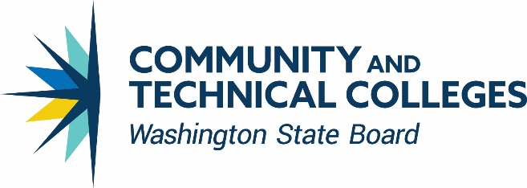

**Basic Education for Adults Staff Areas of Responsibility**

**William Durden** [**wdurden@sbctc.edu**](mailto:wdurden@sbctc.edu) **360-704-4326**

Director

* Strategic Direction Implementation & Management
* Department operations and policy coordination
* WIOA State Plan: Title II

**Katrina Whittle** [**Kwhittle@sbctc.edu**](mailto:Kwhittle@sbctc.edu) **360-704-4323**

Assistant to the Director

* Direct support for Director
* Department administrative/logistical support
* CBS/AEAC meetings and retreats
* OGMS support
* BEdA website maintenance

**Christy Lowder** [**clowder@sbctc.edu**](mailto:clowder@sbctc.edu) **360-704-4331**

Program Specialist III

* GED® Support
* I-BEST: application review/ maintain website / coordinate travel
* BEdA Staff conference/registration/ctcLink support
* BEdA Training Support Coordinator
* BEdA/Corrections website maintenance
* BEdA/Corrections Annual Conferences

**Troy Goracke** [**tgoracke@sbctc.edu**](mailto:tgoracke@sbctc.edu) **360-704-4361**

Policy Associate, Accountability & Compliance, Adult Secondary Completion, Program Approval, and State Legislative Priorities

* Adult High School Completion
* GED Administration
* Accountability/Compliance/Federal Regulations
* Liaison to OSPI/WTECB-IC/WDC/WorkFirst
* RFA- Basic Grant, Continuations, & Yearend Report
* WIOA Technical Support
* Adult Education Advisory Council & Council for Basic Skills

**Hanan Al-Zubaidy** [**hal-zubaidy@sbctc.edu**](mailto:hal-zubaidy@sbctc.edu) **360-704-4358**

Associate Director, Corrections Education

* All Corrections Education Programming & Re-entry
* Prison Education Program (PEP) Implementation
* Washington Association of Community and Technical College (WACTC) Liaison
* Department of Corrections Liaison
* State Legislation
* Corrections Education Annual & Quarterly Reports
* Apprenticeship Work Group

**Chastity Pennington** [**cpennington@sbctc.edu**](mailto:cpennington@sbctc.edu) **360-704-1052**

Program Administrator, Corrections Education

* Corrections Education Navigators
* Corrections Education College Catalogues
* Corrections Education Support Staff
* Corrections Education Professional Development
* Corrections website maintenance

**Nicole Daughtry** [**ndaughtry@sbctc.edu**](mailto:ndaughtry@sbctc.edu) **360-704-4368**

Policy Associate, Guided and I-BEST Pathways

* Pathway Development & Implementation, IELCE Grants, & IET
* Prof. Tech., Expansion, Academic I-BEST
* In/out of state I-BEST TA
* Contextualized Instruction/I-BEST at Work
* I-BEST Navigation & TT Cadres
* I-BEST Liaison Councils/Commissions
* I-BEST @ Work Development, Implementation, and Training

**Katelynn Orellana** [**Korellana@sbctc.edu**](mailto:Korellana@sbctc.edu) **360-704-4362**

Program Administrator

* Professional Development (PD) & PD Calendar
* New Director and Faculty Trainin**g**
* Navigator Trainings & Support
* BEdA Biennial Conference

**Scott Toscano** [**stoscano@sbctc.edu**](mailto:stoscano@sbctc.edu) **360-704-4381**

Relationship and Compliance Analyst

* Assessment Policy & CASAS
* NRS-Data Collection Quality
* Accountability/Compliance/Federal Regulations
* Program Review & Technical Assistance
* Internal & External Data Requests
* WIOA Technical Support

**Jodi Ruback** [**jruback@sbctc.edu**](mailto:jruback@sbctc.edu) **360-704-4306**

Program Administrator

* English Language Acquisition
* eLearning Liaison
* Distance Learning
* Digital Literacy & Digital Equity
* Integrated Digital English Acceleration (I-DEA)
* CBO liaison