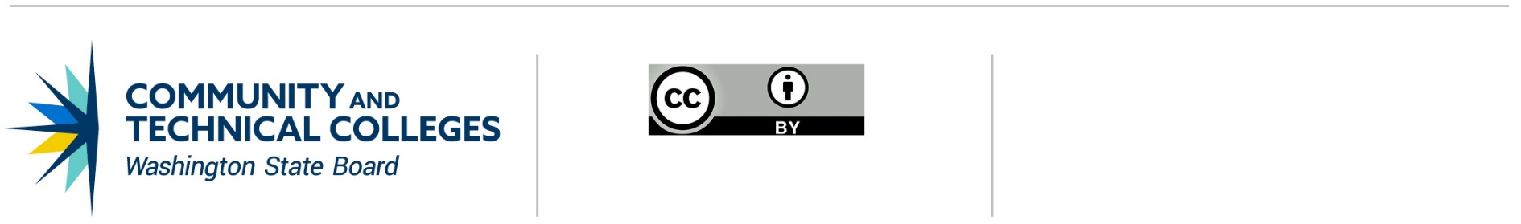

June 21, 2019

# **Professional Technical Common Courses Approval**

# Developing a new course

## Steps to Take

1. The colleges review the existing [Common Course Matrix](https://ccn.sbctc.edu/) for courses similar to the proposed course(s) to see if a course already exists that will meet the colleges’ needs.
2. If there is not an existing course, the colleges convene to develop or modify a common curriculum.
3. The college group identifies a Lead College Contact to represent the consortia of colleges participating in the Professional/Technical Common Course (P/TCC) development. Record that information below:

| **Lead College Contact** | | | | |
| --- | --- | --- | --- | --- |
| **College name** | **Name** | **Title** | **Phone** | **E-Mail** |
|  |  |  |  |  |

Record all participating colleges and points of contact in the chart below.

| **College Name** | **Name** | **Title** | **Phone** | **E-Mail** |
| --- | --- | --- | --- | --- |
|  |  |  |  |  |
|  |  |  |  |  |
|  |  |  |  |  |

| **EXAMPLE E-MAIL** | |
| --- | --- |
| **TO:** | [vtc@lists.ctc.edu](mailto:vtc@lists.ctc.edu) |
| **CC:** | WEC Chair; All Current Participating Colleges |
| **FROM:** | Lead College Contact |
| **SUBJECT:** | Intent to Create New P/T Common Course [Course Subject Area] |
| **BODY:** | The following colleges intend to create new PTCCN in [Course Subject Area]   * College 1 * College 2 * College 3   (ANY PERTINENT INFORMATION REGARDING INTENT.)  Please respond to LEAD COLLEGE CONTACT by SPECIFIC DATE to discuss interest in joining this PTCCN consortia. |

1. The Lead College Contact solicits additional college participation by announcing the intent to create one or more common professional/technical courses on the [Workforce Education Council (VCT) eList](mailto:vtc@lists.ctc.edu).
2. The colleges will review existing Professional/Technical Common Courses on the [Common Course Matrix](https://ccn.sbctc.edu/) one more time. Colleges will agree on a unique course prefix, number and title to avoid identical courses being listed on the Common Course Matrix. [CLICK HERE FOR ADDITIONAL INFORMATION](http://www.sbctc.edu/colleges-staff/programs-services/common-course-numbering/ptccn-rules.aspx).
3. Colleges provide a statement of need for the proposed course(s). Please include evidence of need (Employer request, grant deliverable, licensure or certification requirement, transferability between colleges).

| **Statement of Need** |
| --- |
|  |

1. Colleges jointly agree to the following information for each P/TCC. (Replicate the table below for each course)
   1. In the course description include:
      1. A summary of the course
      2. How it relates to the profession/discipline or how the course meets the requirements of the accrediting agency.
   2. In the topics/skills section provide examples of topics that will be covered in the course and/or skills that will be addressed.
   3. In the course outcomes section list the knowledge, skills and abilities students will have mastered at the completion of the course. Outcomes should be:
      1. Observable
      2. Measurable
      3. Use specific action verbs
      4. Can be demonstrated

Please see the [P/TCC Scoring Rubric](https://www.sbctc.edu/resources/documents/colleges-staff/programs-services/professional-technical/ptccn-rubric2-1-19.docx) for examples.

Colleges may also agree on common curricular elements, textbooks or instructional materials, assessments, equipment and/or other aspects of the course, but those factors are not required and do not need to be listed on the proposal form.

|  | **PREFIX** | **NUMBER** | **P/T COMMON COURSE TITLE** | **CREDITS** |
| --- | --- | --- | --- | --- |
|  |  |  |  |
| **DESCRIPTION** |  | | | |
| **TOPICS/SKILLS** |  | | | |
| **COURSE OUTCOMES** |  | | | |
| **ADOPTING COLLEGES** |  | | | |

1. Each participating college seeks individual approval through its established college process. The Chief Instructional Officer from each college will sigh the P/TCC Assurance Form.
2. The Lead College Contact will submit this checklist, assurance forms and a copy of the P/TCC notification email (step 4) to the WEC Chair for review. The WEC Chain will forward the materials to the P/TCC Subcommittee Chair. The P/TCC Subcommittee will review the following:
   1. The process was followed
   2. College partners were solicited
   3. Evidence of course(s) need is provided
   4. Course description is complete
   5. Student outcomes are well designed
   6. Required protocols were completed

The P/TCC Subcommittee Chair will notify the Lead College Contact and WEC Chair of the subcommittee’s recommendations within fourteen (14) business days via email. The Lead College Contact will notify the other partner colleges of the recommendation.

1. The WEC Chair will submit the P/TCC proposal and P/TCC Subcommittee’s recommendation to chairs of the Articulation and Transfer Council (ACT), Baccalaureate Leadership Council (BAC), and the Instruction Commission (IC) on a quarterly basis. P/TCCs will be considered for final approval in accordance with IC timelines. The IC Chair will communicate feedback and its decision to the WEC Chair.
2. The WEC Chair will send IC’s decision to the Lead College Contact within two (2) business days via e-mail. The Lead College Contact will notify all partnering colleges.
3. The WEC chair will also provide the State Board for Community and Technical Colleges with a copy of this checklist. The [State Board](mailto:kgoebel@sbctc.edu?subject=P/TCC%20Recommendations) will update the [Common Course Matrix](https://ccn.sbctc.edu/).
4. Participating colleges will add the approved Professional/Technical Common Course(s) to their college course catalogs.

**NOTE:** When courses and ***programs*** are being developed simultaneously, each college should submit a separate [Program Approval Request (PAR)](http://www.sbctc.edu/resources/documents/colleges-staff/programs-services/professional-technical/2012PAR.docx) form. The PAR should be submitted after P/TCCs are approved by the Instruction Commission and placed on the Common Course Matrix. [CLICK HERE FOR MORE INFORMATION ON PROF-TECH PROGRAM APPROVAL.](http://www.sbctc.edu/resources/documents/colleges-staff/programs-services/professional-technical/2012ProgramApprovalProcessGuidelines.pdf)

## Assurances

I, NAME OF COLLEGE CHIEF INSTRUCTIONAL OFFICER, affirms that NAME OF COLLEGE has approved the following Professional Technical Common Course(s): (Replicate table for each course.)

|  | **PREFIX** | **NUMBER** | **P/T COMMON COURSE TITLE** | **CREDITS** |
| --- | --- | --- | --- | --- |
|  |  |  |  |
| **DESCRIPTION** |  | | | |
| **TOPICS/SKILLS** |  | | | |
| **COURSE OUTCOMES** |  | | | |
| **ADOPTING COLLEGES** |  | | | |

This institution’s established approval process has been followed and the courses listed above have been approved by the college.

This institution acknowledges that once the courses have been adopted, no modifications are permissible without utilizing the established Professional/Technical Common Course Revision process or Deactivation process.

Approved By:

_____________________________________________________________________________________

SIGNATURE OF CHIEF INSTRUCTIONAL OFFICER DATE

_____________________________________________________________________________________  
PRINTED NAME OF CHIEF INSTRUCTIONAL OFFICER

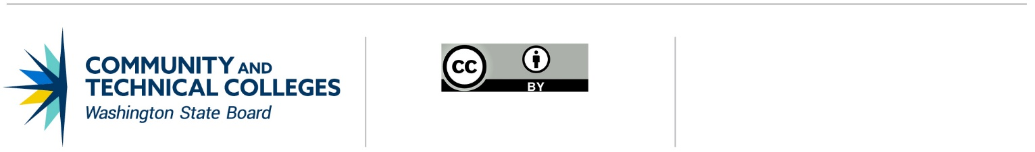

*Note: All material licensed under CC BY.*

CONTACT INFORMATION

Kathy Goebel

Policy Associate, Workforce Education

p: 360-704-4359

e: [kgoebel@sbctc.edu](mailto:kgoebel@sbctc.edu)