Dear student,
Thank you for filling out a help ticket request form for your dual credit class. It is likely that you are unable to login to ctcLink because you haven’t activated your ctclink account yet.
You must activate your account before you can set up your password to login. Follow the steps below to activate your account.
- Enter Skagit.edu into your web browser of choice:
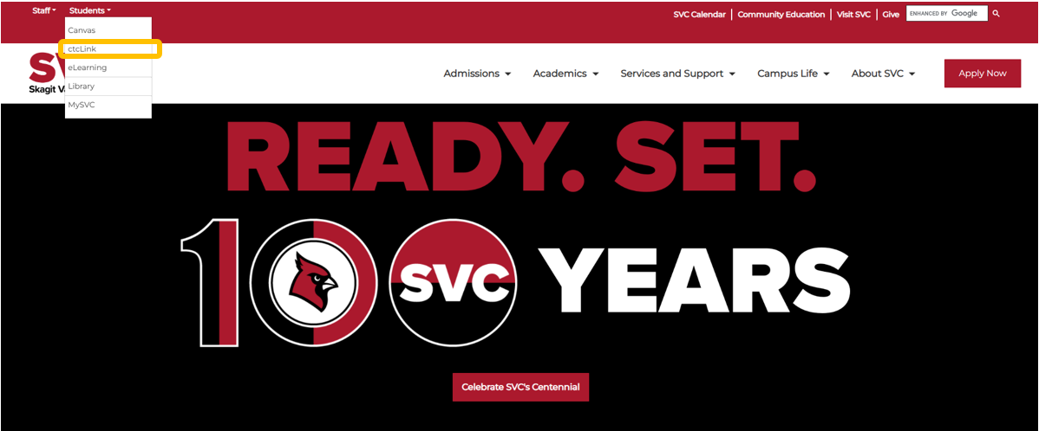
- Navigate to ctclink.
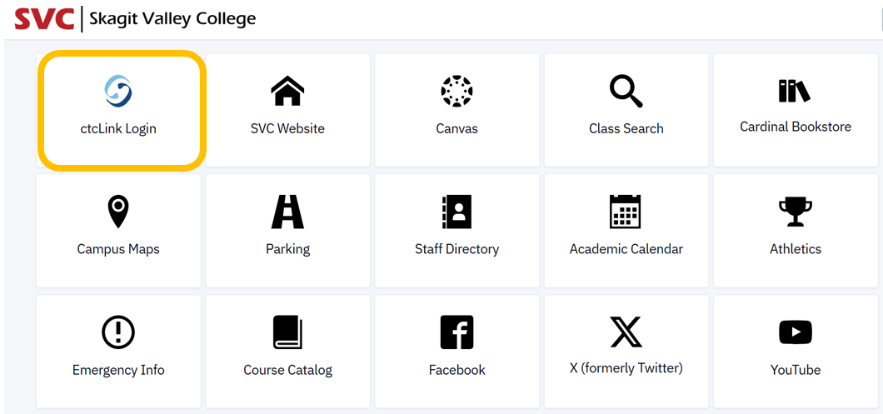
- Activate Your Account.
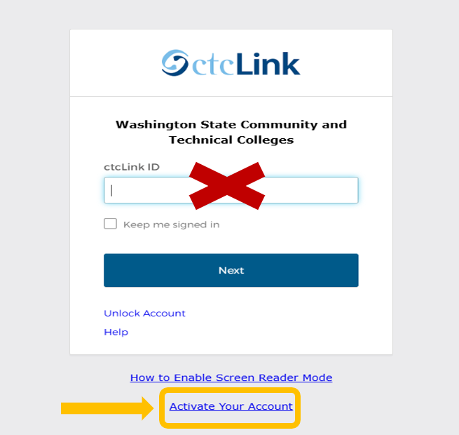
- Set your password to be able to login to ctclink.
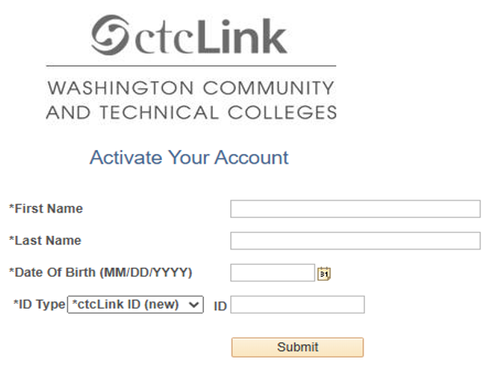
If you are confident that you have activated your account and you still cannot login to ctcLink, please contact IT.helpdesk@skagit.edu for help resetting your ctcLink password.
If you run into additional issues while enrolling in your dual credit course, please email dualcredit@skagit.edu so we can assist you further.

Thank you!

